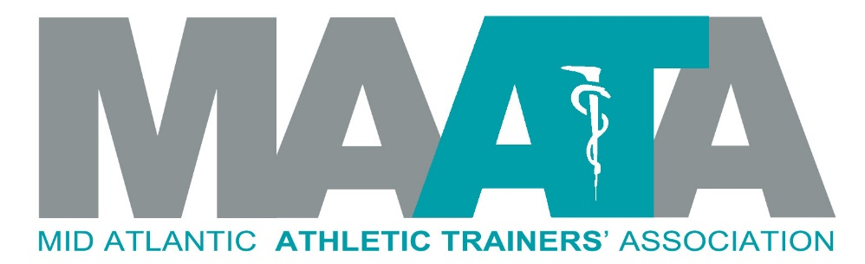
November 60 Second News

District President
Steve Cole
Dear members,
The question isn’t “What is the organization doing for me?” The question is “What are you doing to support our profession and organization?” Are you just putting in time at a job, or are you being a positive role model of our profession through your actions and interactions on a daily basis? Are you looking for ways to promote our profession? Are you seeking opportunities to get involved and engaged with your State organization as well as the Mid-Atlantic Athletic Trainers Association?

For those of our membership who have stepped up in leadership roles, in our State organizations, District and National committees, I congratulate you and truly appreciate your efforts! For those of our membership who voted in our recent election process for the next Director of the Mid-Atlantic Athletic Trainers Association, thank you for getting involved and let your vote be counted.

For those who will ask “What is the organization doing for me?” The question is “What are you doing to support our profession and organization?” I challenge each of you: 1) Now is the time to renew your professional dues. Support our National, District and State organizations. 2) Read the material in the monthly eBlast. 3) Plan to join your colleagues in Charlotte for our annual meeting May 13-15, 2022.

District Director
Katie Walsh Flanagan
Happy Thanksgiving and the official beginning of the Holiday Season! And good luck in playoffs and overlapping seasons. I hope you are all well, happy and healthy, and looking forward to the cooler weather and all it brings

Please join me in welcoming Ray Davis Jr. (NC) as the MAATA Director-elect! Thank you especially to Bob Cable (WV) and Matt Gage (VA) for being willing to put in the effort and time to lead this fantastic District. Ray will shadow (he has already been on several NATA BOD calls) and officially become MAATA Director in June at the NATA Annual Meeting in Philadelphia
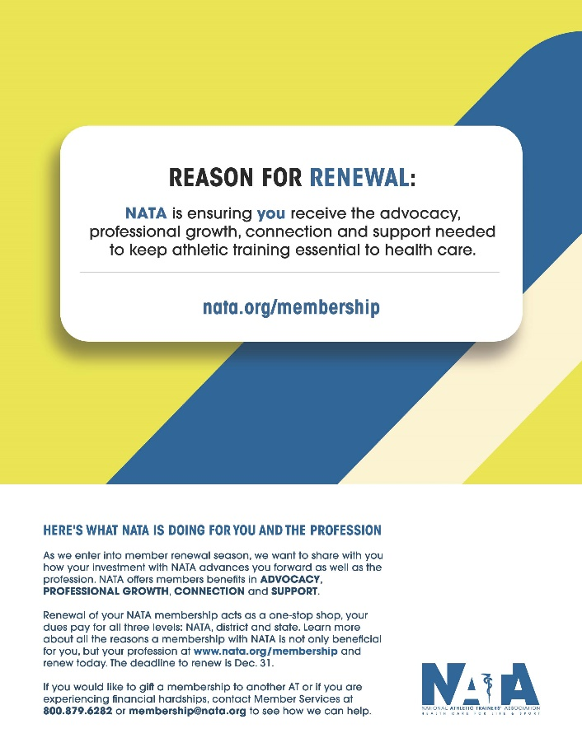
It is NATA Member renewal time! Go to nata.org/membership to join or renew. Also – please pass along that non-members (including students) who join now get the last two months of this year included for free (great info to pass along so students are eligible for scholarships within NATA)

Call for volunteer: the NATA Professional Education Committee has an immediate opening for a MAATA representative to this committee
Professional Education Committee: The PEC supports the collaborative relationship between the profession of athletic training and the educational process. The PEC emphasizes best practices in didactic and clinical education, faculty and preceptor development, and the overall enhancement of professional education in an effort to prepare athletic trainers who are uniquely qualified to excel within a dynamic healthcare system.

Please follow the directions to apply to be the MAATA representative to this national committee via the instructions at https://www.maata.org/d3reps
Deadline to apply: December 1, 2021

District Vice-President
Donita Valentine
Happy Fall!
I am so happy to announce the logistics for our annual meeting and symposium! This in-person event will take place Friday, May 13th through Sunday, May 15th at Hilton Charlotte University Place in Charlotte, NC., and will feature all of our favorite events including a student symposium, social activities, quality educational programming, and the NATA Foundation Breakfast. The call for proposals for the annual meeting is live and will run through December 15th. We will consider all submissions and proposals from within the district are highly encouraged. I am looking forward to seeing you all in May!

NATIONAL UPDATES

Connection & Engagement Committee
Jenni Johnson
The new Connectiveness and Engagement Committee (CEC) wants to remind everyone that we are in renewal season for or NATA membership. The deadline for renewing with a payment plan has been extended. As we enter into member renewal season, we want to share with you how your investment with the NATA advances you forward as well as the profession. NATA offers members benefits in ADVOCACY, PROFESSIONAL GROWTH, CONNECTION, and SUPPORT. Renewal of your NATA membership acts as a one-stop shop, your dues pay for all three levels: NATA, district and state. Learn more about all the reasons a membership with the NATA is not only beneficial for you, but your profession at www.nata.org/membership and renew today. The deadline to renew is December 31. If you are experiencing hardship, the NATA is willing to work with you to facilitate a way to maintain your membership. Also, if you would like to gift a membership to another AT or if you are experiencing financial hardships, contact Member Services at 800-879-6282 or membership@nata.org for assistance!

Governmental Affairs Committee
Ed Strapp
The NATA GAC Committee just finished the last of a 3-part series on advocacy in the legislature. The 3 program recordings are available on the NATA website. Please go to the "Advocacy" tab after logging into NATA website.
Click on "State" and then "State Advocacy Members Only Resources" - you'll find both of the 2021 webinars as well as a handful of other useful advocacy resources. The 3 programs included Day to Day Advocacy, Legislators Demystified: Communicating Value and The Final Preparation: Handling Pressure in the Hot Seat. These are just a few pieces of available material to help states and individual Athletic Trainers feel more comfortable with working around legislators. The GAC continues to provide many resources for states and each of you are welcome to email me with any questions, comments, or concerns!
Stay Safe and Think Snow!
NATA Hall of Fame Committee
Nancy Burke
The NATA Hall of Fame Committee has received a large number of wonderfully dedicated athletic trainers. The selections will be finalized in the New Year and announced publicly in the Spring. Thank you to all who nominated and wrote advocacy letters, it is important to honor those who have made impacts on our profession

Professional Education Committee
Ashley Thrasher
PEC Chats: We have an upcoming PEC Chat for Clinical Education Coordinators on November 18th, 1pm CST. We will be discussing Demonstrating Compliance for Standards 56-94: Beyond a Checklist. This chat is designed as a peer-to-peer discussion. This event is limited to the first 35 registrants, so register soon! Registration link: https://nata.zoom.us/meeting/register/tZ0sf-itrDwiG9dV2MZCCH98bQmotifrgFoB

Teaching Tips: The Professional Education Committee is reintroducing the "Teaching Tips" series! These are short, 7-10 minute videos describing a unique teaching technique. These are similar to model practices at the Athletic Training Educators' Conference. If you have a novel teaching technique and you would like to participate in making a Teaching Tip video, please contact Ashley Thrasher at abthrasher@wcu.edu. For previous teaching tips, click here!

Secondary Schools AT Committee
Shiela Gordon
NATA is proud to have been a member of an interprofessional, virtual event called Health Professions Week, which was hosted November 4 – 11, 2021.

Health Professions Week (HPW) is an exciting week-long event for high school and college students interested in learning more about careers in the health professions. HPW will include an online career scavenger hunt, live interprofessional panel discussions, current student panels, and a virtual fair, featuring NATA and alliance partners. Students, teachers, and parents are invited with free access.

Thank you for all who participated.

Student Leadership Committee
Anthony Corona
Students! Applications for the NATA Student Leadership Committee (2022-2023) are open and hosted on the NATA GATHER portal (https://gather.nata.org/home). The applications will close on November 20, 2021. Also, this month, the NATA SLC will be featured in the NATA Timely Topics! Tune in on November 2nd, 10th, and 18th at 7:00 PM CST to join the discussion on work-life balance, succeeding in your first job, and passing the GRE and BOC! Don't miss out on these incredible opportunities!
The Foundation
Marty Baker
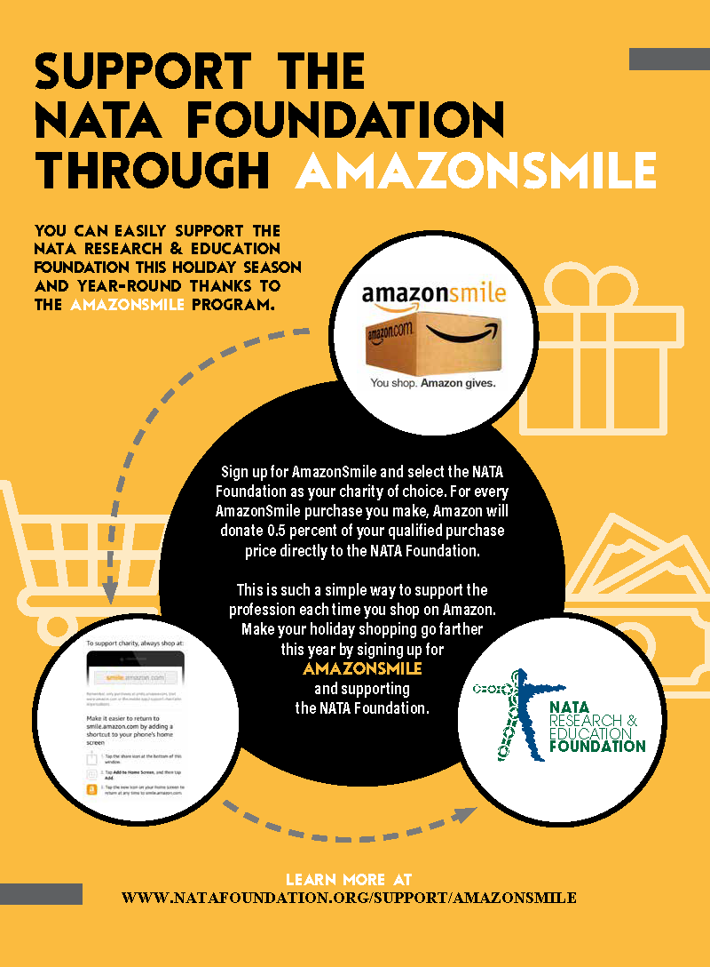
I just love this time of year. The leaves are changing and there is a touch of chill in the air, sadly, soon there will be no fresh tomatoes from the garden. Professionally we go from preventing heat illness to being concerned about exposure. As individuals our efforts go from staying cool to keeping ourselves warm and the holidays are just around the corner.

Talking about the holidays The FoundATion has an initiative that allows you to shop on Amazon and support The FoundATion at the same time and it doesn’t cost you a thing…that should warm everyone’s heart! AMAZONSMILES is The FoundATion’s partnership with Amazon. For every AMAZONSMILE purchase Jeff Bezos and Amazon will contribute 0.5% of the total purchase directly to The FoundATion. Check out the brochure below and please consider this initiative when you shop, not just for the Holidays but the entire year!

I want to say thank you for all MAATA members that participated in The Foundations’ second annual virtual 5K. If you haven’t heard District 8 & the MAATA had a friendly competition to see which district could register the most participants. Sadly D3 lost by one but between D8 & D3 our two districts accounted for nearly 30% of the participants and that makes The FoundATion the big winner.

Here is a big heads up to all Program Directors; students can now submit scholarship applications to The FoundATion. D3 athletic training students have a rich tradition of success in scoring its fair share of support from one of the main missions of The FoundATion…support for the next generation of athletic trainers through scholarships. Please encourage worthy students to complete the online process. Let’s insure D3 has the most winners…or if you’re a foodie…winner, winner chicken dinner! Please direct interested students to:
https://www.natafoundation.org/education/scholarships/apply/

As I close my remarks to you let me say thank you if you support the mission of The FoundATion with your hard earned resources. If you can find it in your heart, mind and wallet please consider a gift if you haven’t recently supported The FoundATion…I promise it will ignite your pilot light and give you a warm sense of satisfaction!
NATAPAC
Mark White
NATAPAC helps us with federal legislation that moves our initiatives forward nationally. To those that donate on a regular basis, thanks. If you have never donated before, make it a point in 2022 to support the NATAPAC. If you have already renewed, you can still donate. NATAPAC has its own website (www.natapac.org), or you can go through the NATA site and visit the NATAPAC page

DISTRICT UPDATES
Educational Program Chair
Zach Garrett
Call for Proposals is now live for the 2022 MAATA Annual Symposium​ May 13 -15, 2022 at the Charlotte Hilton University Place, Charlotte, NC. The deadline for submission is December 15, 2021. We are strongly encouraging proposals from our D3 Members and we are looking for a variety of topics!

A link to the online proposal submission form has been provided below.

https://docs.google.com/forms/d/1Q7masR2z_TuDuEvv_2knv3OY0EQbHun_0cariItW8w0/edit?usp=sharing

If you have any questions regarding this form or presentation requirements, please contact: Zach Garrett (garrett46@marshall.edu). Decisions on submissions will be made within 4 weeks after the deadline.

LGBTQ+ Advisory Committee
Kirk Armstrong
WE WANT YOUR FEEDBACK!

The LGBTQ+ Advisory Committee is asking for your feedback. Please complete this short survey (2 questions) to let us know what resources you need for your professional practice.

We have welcomed two new members to the committee: Mairin Wood (Virginia State Representative) and SooJi Mun (Student Senate Representative).

Honors & Awards Committee
Robert Casmus
The MAATA Honors and Awards are officially closed as the nomination deadline was November 1st, 2021. Thank you to those athletic trainers that have submitted nominations for the May 2022 District III Awards. I ask that the nominators please assist their nominees in completing all the necessary award application forms and help them secure their advocacy letters. All information can be found on the MAATA website under DIII Honors and Awards. All advocacy forms and/or letters of recommendation and the candidate profile/application information must be received by 11/30/21 to be considered for the award to which a nomination was made. We hope to announce our 2022 District III Honor & Awards recipients this coming January 2022.

Scholarship Committee
Adam Weyer
Greetings from South Carolina. I hope that you all had a successful and healthy fall season. The scholarship season is going to be upon us soon and we need your help in getting the word out.

We have four scholarships available for athletic training students in our district. More information about each scholarship can be found here, https://www.maata.org/maata-scholarships. The application period for the scholarships will open on January 1st, 2022 and close on March 1st, 2022. Please encourage your students to apply for these scholarships. We have opportunities for undergraduate students all the way to post-doctoral students.

We are still looking to fill 2 open vacancies on the committee. We need a representative from West Virginia and the District of Columbia. All you need to be able to do is to advocate and advertise these scholarships throughout our district and be willing to review scholarship applications of the extremely talented students in our district. If you are interested in serving the district in this way, please apply via our website -www.maata.org. Also, take a look at the attached pdf on how to apply for open positions in our district by clicking here, https://c81bb2bd-6a68-4229-a346-ea62c8f24774.filesusr.com/ugd/b426d2_37ad31c5c7af4af98a3acbe6f2b782aa.pdf. We would love to have you join the committee.

If you have any questions about the scholarships or about joining our committee, please reach out to me at aweyer@lander.edu. Good luck to all of you as your winter seasons start getting busy.

Student Senate Committee – Emily Hildebrand
The Senate has welcomed 5 new members: Janay Ward (MD), Bryonna Woffter (VA), Alissa McCarty (WV), Jenna Tomlinson (NC), and Savannah Venters (SC). Check out their bios along with our latest newsletter edition on the Student Senate page of the website: https://www.maata.org/studentsenate. Tune into our Instagram page (@maata_student_senate) to provide input on the Student Program held in conjunction with the District III annual symposium coming May 13-15, 2022 in Charlotte, NC. Also, please check out our latest newsletter!

