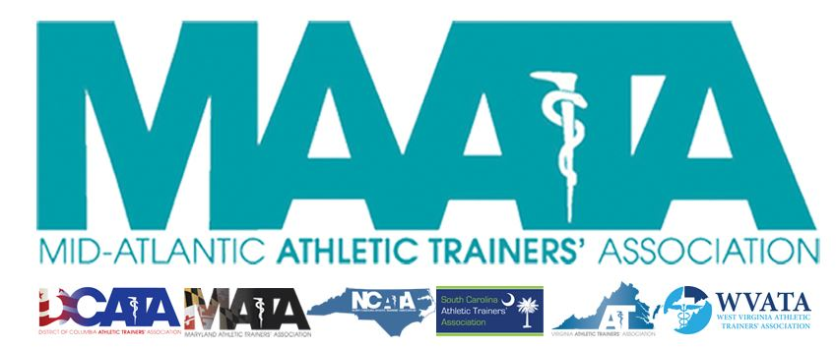

District Council Conference Call Minutes
December 14, 2022
8:30am

- Call to Order

  - President Cole called the meeting to order at approximately 8:33am.

- Roll Call:

  - Members Present:
    - Steve Cole – District President
    - Ray Davis – District Director
    - Donita Valentine – District Vice-President
    - Jason Mitchell – District Secretary
    - Christina Carrillo – President, DCATA
    - Jean Perez – President, MATA
    - Nina Walker – President, NCATA
    - Amy Hand – President, SCATA
    - Danny Carroll – President, VATA
    - Tom Belmaggio – President, WVATA

  - Guests Present:

    - Marty Sataloff – District Parliamentarian
    - Scott Cook – District Vice-President Elect
    - Erin Cash – District Secretary-Elect
    - Zach Garrett – Chair - Educational Program Planning Committee
    - Ed Strapp – Chair – Governmental Affairs Committee
    - Emily Hildebrand – Student Senate Faculty Advisor

  - Members Absent:

    - Jay Sedory – District Treasurer
    - Katie Walsh Flanagan – Past District Director

- District Secretary – Jason Mitchell
  - Approval of minutes of previous District Council Meeting – (11/16/2022)
    - Motion to approve – District Director Davis
      - 2nd – NC President Walker
      - No discussion
    - Passed – 11-0-0
- District President – Steve Cole
  - Old Business
    - Reviewed some additions from the proposed 2023 budget that was reviewed by the Executive Council on 12/12/2022

- NATA Governmental Affairs Committee – Ed Strapp
  - Finished the 1st part of a 2-part Annual reporting
    - In the Fall perform a legislative update for each state with short/long term goals
    - WV
      - Short term: looking at changing language in standards of care & heat illness care
      - Long term: working on mandates for ATs in all of the state schools
    - SC
      - Working to gain full licensure
    - MD
      - In 2nd year of getting dry needling into AT scope of practice
      - Long term: working with coaching organizations on ways of funding an AT at all high schools
    - VA
      - Continue to update practice acts to ensure it continues to be current
  - End of Spring will conduct year-in-review to check status of state goals

- MAATA Educational Program Committee – Zach Garrett
  - Call for proposals has completed
    - 31 submitted proposals, which is double from last year
  - Going through preliminary process of laying out the program schedule
    - Tentatively looking at 13.5 CEUs
  - Looking at different ways to increase revenue for the meeting
    - Looking at company to offer education content online after the in-person meeting

- State Presidents Reports:
  - District of Columbia – Christina Carrillo
    - Gearing up for the DC virtual state business meeting in middle of January
    - 5th Annual Student AT Symposium, sponsored by EDAC, on March 11

  - Maryland – Jean Perez
    - Lobby day is January 12 in Annapolis
    - Tentative date for Annual Meeting – 1st/2nd week of June

  - North Carolina – Nina Walker
    - GAC
      - Heading into a legislative year, and planning several events around meetings with legislators
    - Admittance into the NC Sports Hall of Fame
    - Annual meeting in first weekend of March
      - Beginning to get proposals
    - SAC town hall meeting this week

  - South Carolina – Amy Hand
    - Finalized language with lobbyist on licensure bill yesterday
    - Annual Meeting – July 12-14
      - Call for proposals open until tomorrow
    - Secondary Schools workshop – January 21
      - 1st year to supply CEs for ATs who bring in their students

  - Virginia – Danny Carroll
    - Preparing for the VA annual meeting starting January 13
      - Hosting 1st AT Olympics!
    - Getting ready for start of legislative session in January
      - Looking at needs to update practice acts in order to push dry needling

  - West Virginia – Tom Belmaggio
    - WV Annual Meeting - March 25-26 in Charleston
    - Continuing to work on switching organization from a 501-C3 to a 501-C6 to assist with their legislative initiatives

- District Director – Ray Davis
  - NATA Updates
    - Finalizing some volunteer position openings
    - National budget has been approved
    - NATA Joint Committee meeting in Dallas the last weekend of January
    - NATA Annual Meeting in June in Indianapolis

- District Secretary – Jason Mitchell
  - Presented current District Member & National member data at a glance

- District Vice-President – Donita Valentine
  - Annual Meeting update
    - May 19-21, 2022 @ Founder’s Inn in Virginia Beach, VA
    - Meeting registration – opening January 9
    - Exhibitors’ site is up and ready

- District President – Steve Cole
  - MAATA Updates
    - Scholarship Committee
      - Announced new chair
      - Updating scholarship language
    - Membership renewal incentives
      - $250 award to state organization
        - DC is currently in the lead!
      - Reaching out to all MAATA Hall of Fame members to assist sponsoring the Mentors’ Breakfast
    - Call out for applicants for interim District Treasurer who will complete the remainder of the current term
    - Gave updates with the proposed changes in Constitution & By-Laws
    - Proposed sending out a membership holiday card
      - Unanimously approved continuing to send out to members

- Adjournment of meeting
  - Motion to adjourn meeting – Secretary Mitchell
    - 2nd – VA President Carroll
    - Approved 11-0-0
    - Meeting was adjourned 10:01 am

