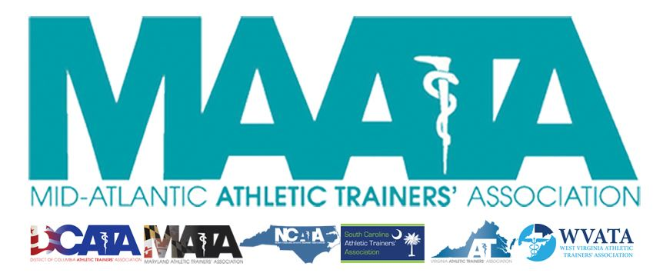

District Council Conference Call Minutes
October 16, 2019
10:00am

- Call to Order

  - Director Flanagan called the meeting to order at approximately 10am.

- Roll Call:

  - Members Present:
    - Katie Walsh Flanagan – District Director
    - Jason Mitchell – District Secretary (joined later during State President reports)
    - Mike Walker – President, DCATA
    - Wes Robinson – President, MATA
    - Jim Bazluki – President, NCATA
    - Brad Drake – President, SCATA
    - Jenni Johnson – President, WVATA

  - Guests Present:

    - Marty Sataloff –District Parliamentarian
    - Scott Cook – MAATA Annual Meeting Planner
    - Emily Hildebrand – Student Senate Advisor
    - Kim Pritchard – Educational Meeting Planner

  - Members and Guests Absent:

    - Ray Davis – District Treasurer
    - Patricia Aronson – Past District Director
    - Scott Powers – President, VATA
    - Jay Sedory – Treasurer-elect

- Updates – Director Flanagan

  - NATA BOD Updates
    - Thoughts on GLATA restructuring
      - All still in favor – no questions
    - Other BOD News impacting MAATA
  - MAATA Updates
    - Restructuring
      - Moving forward with re-structuring
        - Motion – Jenni Johnson, WVATA President
          - 2nd – Jim Bazluki, NCATA President
          - Passed – 6-0-0
    - Team UP for Sports Safety – TUFSS (NATA/KSI initiative)
      - They were in MD last week, & coming to District 3 Meeting & NC next May
    - Committee openings
    - ATs Care & Clinical Coordinator
      - We are a district-based (not state-based) committee and will remain until WV & SC get up to speed. Will seek a District Clinical Coordinator (mental health care provider) to volunteer services to district. When we become state-based, each state will need one

- Annual Meeting Updates – Scott Cook

  - May 15-17, 2020 @ Hilton Charlotte University Place
    - Same location for 2020-2022
    - NASCAR All-Star
  - Discussed overall meeting schedule/highlights/sponsorships
  - Discontinuing Wild Apricot for registration services
    - Transitioning to Google Forms & PayPal
    - Planning for registration going live Monday, November 4th
      - Hotel reservation links going live at similar time
  - Distributed out projected registration pricing model to the Council

- Educational Planning Committee Updates – Kim Pritchard

  - Call for Proposals deadline is November 1
    - Looking at 2 potential Pre Con workshops
    - Potential Total CEs (excluding workshops): 8 EBPs/6.5 Cat A

- Student Senate Updates – Emily Hildebrand

  - The Student Senate is currently voting on new junior senators
    - Received 11 total applications (MD:3/NC:1/SC:2/VA:3/WV:2)
      - 3 of these are from ATPs that previously have not been represented
      - First time we received professional graduate (MSAT) student applications
  - State Presidents – please provide any state information to student senator rep
    - They have already made contact in August, and will send inquiries around middle of every month
    - We include this information in the monthly newsletter and on social media sites.
      - Newsletter is emailed to you monthly and can always be found on MAATA website so we ask your support in disseminating content to encourage involvement from all ATPs in the District
  - Working with Kim Pritchard, the educational chair, to finalize the Student Program in Charlotte

- State Presidents Updates:
  - District of Columbia – Mike Walker
    - We had our fall business meeting and CE event last week
      - We had an orthopedic physician speak about ACL repair vs. reconstruction. I would have liked more people to have attended the meeting, but it was nice to see some new faces.
    - Our Licensure is finalized and signed by the Mayor but there has been no movements in regards to our Practice Act. We have made attempts to contact the Board of Medicine and get working on the Practice Act but they have been hesitant in getting back to us. Our lobbyist is working to get attention from the Board of Medicine as well.
    - We will be having our 4th Annual Student AT Symposium in March.
      - We are currently developing the curriculum for the day and hopefully finding sponsors to help with the financials

  - Maryland – Wes Robinson
    - Recently completed KSI TUFSS meeting.
      - This was a good meeting and great start to organizing the state.
    - We will be initiating a Diversity, Equity & Inclusion Committee with Rachel Moore as the Chair
    - We are continuing our push for this upcoming 2020 legislative session in Annapolis
      - The goal is to expand our practice act to broaden the reach of Athletic Training Services in the state of Maryland. We have some significant restrictions in our current law in regards to practice setting and patient definitions
    - MATA has had a great inroad into working with our state EMS board to change the state protocol to include “cool first, transport second.” We anticipate these changes will become effective when the next protocol cycle goes live July 2020
    - State Symposium will be 5/30 and 5K run 5/31

  - Virginia – Scott Powers (report sent electronically)
    - President Powers and Secondary School Chair Jenn Armstrong did a joint symposium with Blue Ridge Area VPTA meeting on concussion
    - Two piece of legislation will be presented in January to NA General Assembly
    - President, TPR Task Force Leader, and GAC Chair will be attending the Wisconsin TPR conference in November
    - Secondary School Symposium will be December 13-14
      - 9 EBPs/3 Cat A
    - Annual Meeting is January 4-5.
      - Friday will have Pre Con workshops. Main meeting is Sat/Sun with 5 EBP and 5 Cat A.
    - VA Medical Advisory Board for Athletic Training will be addressing the membership on practice act and license issues
    - VATA Leadership Academy is successfully leading the first cohort through the program

  - West Virginia – Jenni Johnson
    - After licensure, we sat with the PT board to review rules and regulations
      - No public comments with any criticisms
      - Good to go with licensure effective January 1
    - Sad news in DC
      - Sustained a high school death
        - Pushing Secondary Schools for appropriate health care
        - WV only mandates coverage for high school football from a “Football Trainer”
          - This coverage does not have to be a Certified Athletic Trainer
          - No minimum requirements on who this can be.
        - Pushing to meet with the WV State Board of Education & Secondary Schools commission to work on that
    - Changing state meeting this year to April 4-5 in Morgantown

- Final Announcements/Comments – Director Flanagan
  - Governmental Affairs Grants - $64k for the District – Congratulations!
  - Go4Ellis is now in D3 – per diem $$ for AT Services

  - Annual Business Meeting will now be on the Friday schedule of our MAATA meeting.
  - Secretary Mitchell
    - Initiatives to push the last-minute NATA membership renewals
      - Currently, D3 renewals looking good
- Adjourn – Director Flanagan
  - Motion – Treasurer Mitchell
    - 2nd – Jenni Johnson, WVATA President

