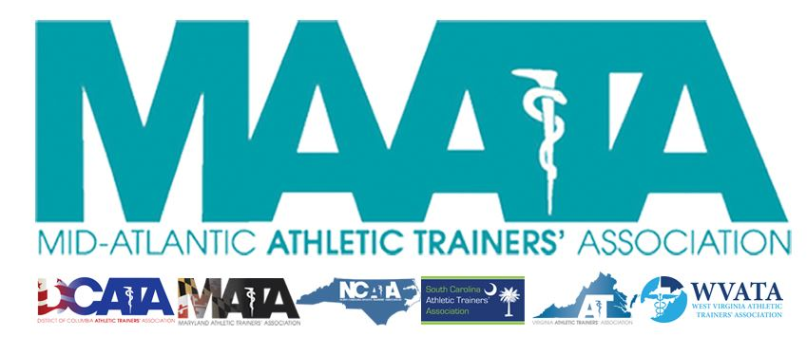

District Business Meeting Minutes
May 17, 2019
5:00pm

- Call to Order
  - Director Flanagan called the meeting to order at approximately 5pm.
- Establish a Quorum
  - Approved - Marty Sataloff – District Parliamentarian
- Moment of Silence/Remembrance
- Approval of minutes of 2018 Business Meeting (5/1/2018)
  - Motion to approve – Bob Casmus
    - 2nd – Scott Johnson
    - Passed by verbal vote
- Secretary Report – Jason Mitchell
  - Discussed District Membership data
- Treasurer Report – Ray Davis
  - Discussed 2019 expenses/finances and upcoming budget
- New Business
  - By-Law Proposed Change
    - Requested Change:
      - Section 5.3 – MAATA Committees will be formed in accordance to Article 10.1 in the MAATA Constitution
    - Requested deletion:
      - Section 5.3 – Committee chairs shall appoint representatives from each state and the District of Columbia for their respective MAATA committee.
      - Section 5.4 – The District representative to a national committee shall inform the Executive Council of the state representatives via the District Secretary.
    - Motion to approve - Scott Johnson
      - 2nd - Bob Casmus
      - Call to question – Marty Sataloff
      - No discussion
      - Unanimous approval by verbal vote
- MAATA Election Committee – Pat Aronson
  - Discuss timeline/details for upcoming elections and terms for District Director/Secretary/Treasurer
- MAATA/NATA Reports
  - MAATA Annual Meeting Planner – Scott Cook
    - Discuss overall registration data
  - MAATA Educational Program Chair – Kim Pritchard
    - Provided overall review of educational schedule
  - NATA Foundation – Jill Manner
    - Announced scholarship winners ($2300 each)
    - Announced NATA Grants & Award winners (over $14000 given to D3)
    - Promoted Silent Auction in Exhibit Halls
  - NATA PAC – Mark White
    - Overviewed finances
  - CAATE – Barbara Long
    - CAATE hired new executive director – Danielle Baron
    - Overviewed number/status of professional AT programs
- Director’s Report – Katie Walsh Flanagan
  - Please utilize our webpage (www.maata.org)
    - Continue to review & submit materials to D3 publications
  - News from NATA
    - Please join GATher
      - Allows NATA members to connect online with topics that are important to you
    - Military Jobs Initiative
    - 3rd-Party Reimbursement Project is Completed
    - Please note that State Legislators are notified of SSSA Award Winners
    - Discussed Sideline USA program
    - Promoted per diem program Go4Ellis
    - Bureau of Labor Statistics believes AT will grow exponentially in coming years
    - Encouraged members to obtain your NPI number
      - Currently at 54% of NATA members
      - Register for yours today @ http://nppes.cms.hhs.gov
    - New member benefit
      - NATA Survey Research Service
        - Student members get 1000 free surveys for IRB complete work.
  - Discussed new documents from the NATA for members to review
  - News from the NATA BOD
    - Updated structure/mission of the Commission on Practice Advancement (COPA)
    - Alliance approved document “Guidelines and Consideration for Athletic Training Regulatory Language”
    - Kory Stringer Institute
      - Provide quality services
      - NATA is the largest contributor to KSI
    - Future NATA Meetings
      - 2020 – June 17-20, Atlanta, GA
      - 2021 – June 24-27, Orlando, FL
      - 2022 – June 17-20, Philadelphia, PA
- D3 Committee Reports
  - Ethnic Diversity – Brittany Brown
    - Introduced State Representatives and program updates
  - LGBTQ+AC – Ami Adams
    - Promoted State Resource Sheet
  - Public Relations – Tina Carrillo
    - Announced NC names national PR winner for best state
      - 4th year in the row
    - Encouraged membership to continue submitting ideas for the District PR platforms
  - Scholarship Committee – Joe Beckett
    - Announced committee members
    - Encouraged members to apply for scholarships
  - Secondary Schools AT Committee – Jennifer Rheeling (on behalf of Sheila Gordon)
    - Overviewed the MAATA Safe Sport Grant Program
    - Encourage for ATLAS project surveys being completed annually to ensure accurate information
  - Memorial Resolutions – John Bielawski
    - Promoting the initial progress.
    - Notifications will appear in District Publications
    - Moment of Silence for members who have passed
- D3 Rep to NATA Committee
  - ATs Care – Donita Valentine
    - Overviewed status of critical incidents & services renders
      - 32 D3 critical incidents reported
        - 21 ATs Care services have been rendered/15 where ATs were directly involved
  - NATA Ethnic Diversity AC - Brittany Brown
    - Announced schedule at NATA meeting – Las Vegas
  - NATA Specialty Award – Bob Casmus
    - Committee currently editing the scoring tools to be more reflective of the award criteria.
  - NATA Hall of Fame – John Bielawski
    - 2019 HOF class consisted of 27 nominations
      - District 3 received 3 nominations
        - 1 D3 awarded
  - LGBTQ+ AC – Ami Adams
    - Announced Town Hall @ NATA Meeting – Las Vegas
    - Please follow us social media
    - If you missed the D3 Safe Space Ally Training, another session will be conducted in Las Vegas
  - NATA Professional Responsibility in AT – Joe Beckett
    - Discussed purpose and initiatives of committee
  - NATA State Association AC – Jennifer Rheeling
    - Reviewed State Leadership Forum for all state leaders
    - NPI # Project
      - Exploring methods for greater compliance
  - NATA Young Professional’s – Amy Hand
    - Announced incoming chair – Kelley Crowe
    - Discussed work on Best Practices for Working Per Diem document
    - Discussed future events at D3 & NATA meetings
- Awards – Katie Walsh Flanagan
  - Announced all D3 District & National award winners
- Announcements – Katie Walsh Flanagan
  - Committees slides from this presentation will be posted Monday on our “Members Only” section within our website (www.maata.org)
- District IV Restructuring – Craig Voll – D4 Director
  - Presentation slides will be posted Monday on our “Members Only” section within our website (www.maata.org)
- Motion to adjourn – Bob Casmus
  - 2nd – Scott Johnson
  - No Discussion
  - Director Flanagan adjourned the meeting at 6:24pm

