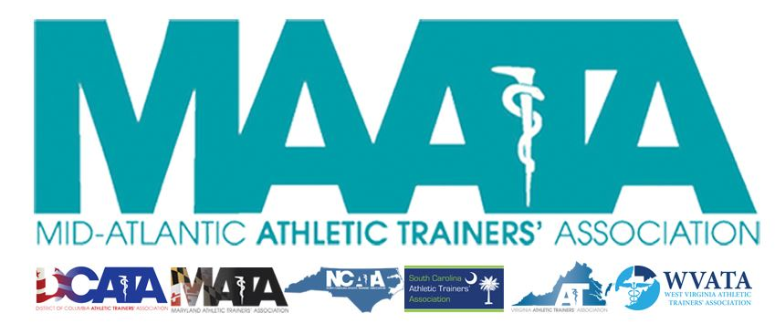

District Council Conference Call Minutes
September 21, 2022
8:30am

- Call to Order

  - President Cole called the meeting to order at approximately 8:30am.

- Roll Call:

  - Members Present:
    - Steve Cole – District President
    - Ray Davis – District Director
    - Jason Mitchell – District Secretary
    - Jay Sedory – District Treasurer
    - Katie Walsh Flanagan – Past District Director
    - Shannon Fooks – Vice-President, DCATA
    - Jean Perez – President, MATA
    - Nina Walker – President, NCATA
    - Amy Hand – President, SCATA
    - Danny Carroll – President, VATA
    - Tom Belmaggio – President, WVATA

  - Guests Present:

    - Marty Sataloff – District Parliamentarian
    - Emily Hildebrand – Student Senate Faculty Advisor

  - Members Absent:

    - Christina Carrillo – President, DCATA
    - Donita Valentine – District Vice-President

- District Secretary – Jason Mitchell
  - Approval of minutes of previous District Council Meeting – (05/13/2022)
    - Motion to approve – VA President Carroll
      - 2nd – Treasurer Sedory
      - No discussion
    - Passed – 10-0-0

- District Director – Ray Davis
  - NATA Updates
    - Pushing to fill volunteer positions
    - Encourage use of gATher and overall social media
    - NATA Strategic plan (4 goals) – meeting with District/State leadership October 4
      - Will be presenting to multiple membership groups to disseminate the information
    - Will be reaching out to each State President to coordinate state representatives to all committees

- Past-District Director – Katie Walsh Flanagan
  - Election Updates
    - Presented potential candidates to comprise the Elections Committee
      - District Council must vote to approve potential candidates before the Elections Committee can begin their process
      - Motion to approve potential candidates – Secretary Mitchell
      - 2nd – MD President Perez
      - Passed – 10-0-0

- District Secretary – Jason Mitchell
  - DST update
    - Access to non-renewed members
  - Presented current District Member & National member data at a glance

- District Vice-President – Donita Valentine (reported by President Cole)
  - Annual Meeting update
    - May 19-21, 2022 @ Founder’s Inn in Virginia Beach, VA
    - Call for Proposals – early October
    - Meeting registration – opening January 9

- District Treasurer – Jay Sedory
  - Discussed current financial report
    - Deadline for submission of financial proposals is September 25
    - Financial Advisory Committee will review all proposals in determining next year’s budget
    - Plan is to have 2023 budget confirmed by November

- District President – Steve Cole
  - MAATA Updates
    - Governance Task Force update
      - First call last month
        - Next meeting, September 28
    - Committee Liaisons
      - Continue to get updates on Committee member updates
      - Encourage continued participation of District Council members with their respective Committee Liaison roles
      - Several vacancies for district committee state representatives
    - Annual Meeting RFPs
      - Renee Cork has been diligently with HelmsBriscoe to begin identifying locations for our Annual Meeting for 2025 & 2026
    - NATA Strategic Plan Call - October 4
    - Future District Council Meetings (Oct 19/Nov 16/Dec 14)

- Student Senate Updates – Emily Hildebrand
  - Continue to promote filling Student Senate positions for each state
    - Applications due Sept 30
    - State Presidents will vote on their respective state candidates
    - Janay Ward – elected by the Student Senators to be Senate President

- State Presidents Reports:
  - District of Columbia – Shannon Fooks
    - Inaugural awards ceremony was well received and a special event
    - Virtual state meeting
      - Strategizing ways to increase attendance in future meetings

  - Maryland – Jean Perez
    - Planning for next year’s State meeting
      - Dates TBD, looking at different dates in the year to maximize attendance
    - Just passed Gorman bill which addresses several safety issues in secondary schools
    - Trying to push Dry Needling again during this legislative cycle
      - Passed Senate last time, but didn’t get thru the House
        - Hopeful that additional support this year to push it thru

  - North Carolina – Nina Walker
    - DEI series has been going very well
      - 10-15 minutes of education with follow-up discussions
    - Working with National Center for Catastrophic Sports Injury Research
      - Each state has representation and coordinating/ensuring any catastrophic injuries are documented
    - Working on Task Force with the NC Department of Health Services
      - Goals to help reduce child fatalities, including those from sports
      - Helping establish minimal standards for child health & safety

  - South Carolina – Amy Hand
    - Finishing up closing out from July Annual State Meeting
    - Interviewing lobbyists
      - Made offer to one firm this past week, with hopes to get started October 1

  - Virginia – Danny Carroll
    - In full swing in planning for the VA State Annual Meeting
      - January 13-15, 2023, in Harrisonburg, VA
      - Search underway in the future site for the next 3 years
    - Looking into strategies is helping members integrate the new CAATE standards into clinical practice

  - West Virginia – Tom Belmaggio
    - Drafting up a Safe Sport bill, which includes that EAPs, heat-illness plans, tackling education (for football), concussion education, CPR/AED certification need to be implemented with all youth sports participation
    - Pushing forward with bill for an AT in every Secondary Schools

- Other Updates
  - Student Leadership Committee - town hall for all state leaders
    - Topic: Funding/Fund raising
    - October 19 @ noon
  - LGBTQ+
    - Recruiting members to complete committee state reps
    - Developing resources for Program Directors to assist with DEI within programming
  - Research & Grants committee - October 1 deadline for submissions

- Adjournment of meeting
  - Motion to adjourn meeting – VA President Carroll
    - 2nd – NC President Walker
    - Approved 10-0-0
    - Meeting was adjourned 9:57am.

