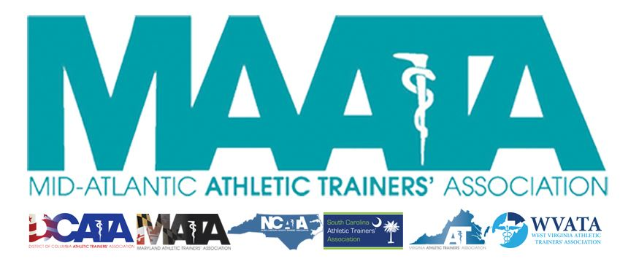

District Council Conference Call Minutes
September 26, 2018
12:00pm

- Call to Order

  - Director Flanagan called the meeting to order at approximately 12pm.

- Roll Call:

  - Members Present:
    - Katie Walsh Flanagan – District Director
    - Jason Mitchell – District Secretary
    - Patricia Aronson – Past Director
    - Sean Dash – President, DCATA
    - Nick Pitruzzella – Interim President, MATA
    - Jim Bazluki – President, NCATA
    - Brad Drake – President, SCATA
    - Scott Powers – President, VATA

  - Guests Present:

    - Marty Sataloff –District Parliamentarian
    - Kim Pritchard – MAATA Educational Program Chair
    - Emily Hildebrand – MAATA Student Educational Program Chair

  - Members and Guests Absent:

    - Ray Davis – District Treasurer
    - Wes Robinson – President, MATA
    - Jenni Johnson – President, WVATA

- NATA Updates:

  - Director Flanagan discussed Licensure Clarity Bill. It will probably be heard this week. It has been lumped together with an FAA reauthorization bill and a $1.6 billion hurricane relief fund, which makes it passage more probable.
  - CAATE announced new ED Danielle Barton. Should receive addition info in the coming weeks/months.
  - Webinars, produced by the Foundation, being put out to membership. Topics will focus around NATA Position stances. They are working with the BOC to see if they can use these as CE opportunities.
- District 3 Updates:

  - Director Flanagan discuss transition of District Secretary to Jason Mitchell, who was selected by EC. Former & current Secretary have work well together to ensure seamless transition. She encouraged the District Council to reach out to Lori Bristow (lbristow@gilman.edu) to extend their well wishes and congratulations on her new professional position.
  - District 10 board member encouraged distribution of the AT football helmets stickers (shape as the involved state).
    - MD/VA/WV – all currently have stickers and have distributed them to their corresponding state schools (~100 to those identified as Safe School)
    - This is a great way to promote our profession. Director Flanagan encouraged state presidents to decide how they would like to proceed with this initiative.
  - COMMITTEE UPDATES:
    - New committees to our states:
      - EDAC put out a call for state members:
        - Collin Francis (Baltimore Ravens) – MD
        - Janah Fletcher (Head AT FB NC A&T)– NC
        - Brandon Holland (AT Gar-Field HS) – VA
      - LGBTQ+ - Chaired by Ami Adams
        - Has interviewed candidates and will have updated info soon
      - YP – new state committee reps
        - Caroline Siebens (Towson) – MD
        - Jared Williams (USC) – SC
        - The Chair (Amy Hand) has shared great letters/information with these new committees to help transition new state members. Great collaboration!
      - NATA committees reps - selected by NATA committee chairs
        - Kelly Crowe (MedStar Sports Med) – MD – YP
        - Scott Johnson (ODU) – VA – Honors & Awards – Service Award
        - Peter Kotz (OLGC HS) – MD - Honors & Awards – MDAT
      - ICSM – Andy Carter/Ernest Eugene left their posts within D3
        - D3 is guaranteed a rep within ISCM, but not a specific # of positions or the most-recently vacated positions
          - New D3 rep – Jennifer O’Donoghue (AT NC State) – also rep for ACC
  - Director Flanagan encouraged all District leaders to submit materials to District Secretary for the upcoming Fall Newsletter. We like to brag on the District to other BOD members.
  - Hurricane Florence
    - Spoke with Jim Berry (Conway, SC) and members within UNCW and Coastal Carolina
      - None these areas’ schools are back in session, and only time will tell to understand their needs.
    - Bonnie Van Lunen (ODU) reached out to Director Flanagan, and she is bringing a truck of supplies to a center in ECU to distribute to affected areas.
    - NATA/MAATA does have link through ATs Care RE Hurricane Florence
      - This is NOT directed towards AT specifically
        - It’s focused specifically on a small SC area that was desecrated, who’s people need assistance
      - Encourage State Presidents to look into AT-specific initiatives

- State Presidents Updates:
  - Director Flanagan wanted to have State Presidents affected by Hurricane Florence to speak first
  - North Carolina
    - NC has sent out to membership Eblasts/posts on social media asking completion of Google Doc on specific needs
      - Once compiled, plan is to create an Amazon wish list for members to access to purchase/send items that members really need (profession & personal)
    - Possibility of waiving state registration fees for members affected by the hurricane
      - Director Flanagan commented to create a mechanism to ensure those affected are those receiving these benefits.
      - Also encouraged that this information moves up to the District level and NATA level, to increase support.
  - South Carolina
    - SC has also reached out to membership
      - Phoned area schools in counties hit the hardest by flooding
    - Had 1 AT who SC wanted to assist from state/district level, Annaleza Jones
      - Her house is 3ft underwater, and probably is a total loss
      - Director Flanagan added that she personally contact her to assist her in exhausting all resources
    - SC elected Rachel Sharpe as new State Secretary
    - SC appointed first State Treasurer, Garrett Williams
    - In process of updating state statute
      - Changing verbage/terminology
      - Add language to implement monetary penalties those who practice outside of credential standards
      - Will open regulations, so opening it up to the SC members
  - District of Columbia
    - DC stated that they were able to get AT State Licensure under the Board of Physicians
      - Still pushing to add “other physical activity” to State Practice Act
  - Maryland
    - Discussed Pt death in College Park, MD
      - MD president will be on administrative leave until UMD details are finalized
        - Nick Pitruzzella will serve as acting MD President during this time
      - Notice to MD members within the next 24 hours
    - Director Flanagan expressed immense gratitude for Nick’s stepping up to serve again during these times
  - Virginia
    - VA has update their website for members
    - Also have upgraded the way the State Treasurer tracks finances
      - Both, in place, will help assist transition administration to administration
    - Planning 2019 State meeting this upcoming January
      - 8 EBPs
      - Also secured site for 2020-2021 meetings
- Guest Updates
  - Kim Pritchard
    - Encourage all leaders to ask state members to submit proposals.
      - Current deadline is Oct. 15
        - Will most likely extend deadline due to Hurricane Florence
      - Focus for this year’s meeting is CAATE Standard 7
        - Evaluation/Management of Pt with life threatening/emergent acute conditions
  - Emily Hildebrand
    - Beginning voting process for incoming Junior-level Student Senators
      - Deadline for applications is Oct 1
    - Will send messages to State Presidents reminding that they are involved in voting process
    - Student Senate Service Project
      - Looking into something related to Hurricane Florence
        - Will coordinate with NC/SC leadership for assistance

- Final Announcements/Comments
  - Secretary Mitchell
    - Submission deadline for Fall Newsletter September 30 @ 12pmEST
      - Publishing around October 15th
    - Currently updating District Dropbox account
      - Implementing addition info for State Presidents

- Director Flanagan adjourned the meeting at 12:31pm.

