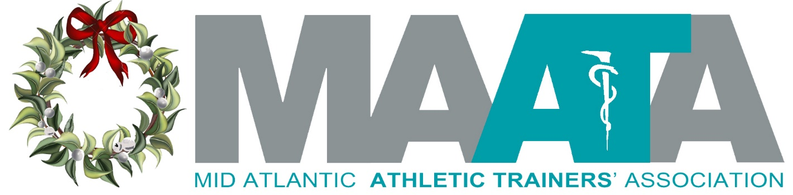

District President
Steve Cole

As we hear so often, “What is the NATA doing for me?” I found an answer in the recent NATAPAC newsletter. Currently the NATA is monitoring more than 85 Federal bills impacting health care, physical activity, and sport-related programs. During 2020, the NATAPAC made campaign contributions to 57 candidates in support of their election; 56 won their election!

On Friday, December 3rd, I was on a call with the Annual Meeting planning committee. They are making good progress and we are all very excited to get together in Charlotte, May 13-15, 2022.

I hope everyone had an enjoyable Thanksgiving and looking forward to a festive Holiday season.

District Director
Katie Walsh Flanagan

Happy Holidays MAATA!

It is my hope that in a time of sport transition, post-season play and tournaments, that you and your loved ones make time for the simple things – enjoy the moments, spend time together and relish in good health and great fellowship. Make yourself a priority too. Happy Holiday Season to all

Please welcome Adam Wall III (NC) as the incoming MAATA representative to the Secondary Schools Athletic Training Committee (SSATC). Adam will shadow Sheila Gordon until June when her term expires and will then take over under the leadership of chairwoman, Jennifer Rheeling. Welcome aboard Adam!

MAATA needs two Volunteers to represent D3 on NATA committees:

We have an immediate opening for a MAATA D3 member to serve on the NATA Post Professional Education Committee – description below
Post Professional Education Committee: The PPEC provides strategic vision and guidance to all post-professional education in athletic training. The promotion of life-long learning and professional development will impart advanced knowledge and skills of athletic trainers to achieve career goals and fulfillment, while also excelling in the clinical practice, research and scholarship that enhances the quality of patient care, optimizing outcomes, and improving patients’ health-related quality of life.

Also needed is a volunteer to join the Education Advancement Committee. This person will join the committee in January and shadow Lindsey Schroeder, EdD, and assume a full committee position when her term ends at the NATA Symposium in June
Education Advancement Committee: The EAC identifies short-term and long-term educational research priorities to advance evidence-based scholarship and to continually assess best practices related to athletic training education in order to enhance clinical practice and patient care.

Applications for both positions can be found on our website (www.maata.org) at https://www.maata.org/d3reps Screening will begin on December 20, and continue until filled.

The NATA Board of Directors is working hard behind the scenes to shore up the Joint Committee Meeting in January. During this time ALL NATA committees are working virtually and collectively on many projects related to their committee charge, in addition to addressing diversity, equity and inclusion within their unique perspectives. I am looking forward to greAT things coming from these focused meetings

District Vice-President
Donita Valentine

Season’s Greetings!!

It is hard to believe that we are winding down the year 2021! As we reflect on the National Athletic Trainers Association’s theme for 2021, #BUILTFORTHIS, and think of all that we have accomplished this past year and all the great things we anticipate in 2022. Built for This was created to highlight the versatility of athletic trainers equipped with a foundational skill set to handle just about any situation we face.

This time of year, and every other time of year is busy for athletic trainers, here are a few additional fun days to look forward to in December.

Dec 15th National Cupcake Day
Dec. 16th National Chocolate Covered Anything Day
Dec. 18th National Answer the Phone Like Buddy the Elf Day
Dec. 28th National Call a Friend Day

Don’t forget to report your CEUs and if you are a few short head on over to the NATA’s website where the NATA Education Encore Registration has been extended to December 15th, once purchased you will have until 12/31/21 @ 11:59 PM CST to consume content and earn CEUs. Also, please be mindful of the MAATA’s policy on CEU certificate distribution as the CEU deadline approaches:

2021 MAATA Virtual Meeting CE Certificates
All requests for the 2021 MAATA Virtual Educational Symposium CE Certificates earned, but not received, must be made in writing by email to Donita Valentine, Annual Meeting Planner, maatameetingplanner@gmail.com, prior to July 31st
Any requests made after July 31st for the 2021 MAATA Virtual Educational Symposium CE Certificates earned, but not received, must be made in writing by email to Donita Valentine, Annual Meeting Planner, maatameetingplanner@gmail.com and the MAATA Treasurer (cfo.maata@gmail.com) to obtain the mailing address where a check (payable to “MAATA”) for $25 for each certificate can be mailed. A $25.00 fee per certificate will be assessed for each request. After August 31st no CE Certificates will be issued.

Be on the lookout for symposium registration to open in late January – early February.
Please continue to stay safe, and I thank you all for your continued support of the MAATA and look forward to seeing you all in May at the MAATA Symposium in Charlotte, NC.

MAATA Symposium
Educational Program Committee
Zach Garrett

Call for Proposals is live for the 2022 MAATA Annual Symposium​ May 13 -15, 2022 at the Charlotte Hilton University Place, Charlotte, NC. The deadline for submission is December 15, 2021. We are strongly encouraging proposals from our D3 Members and we are looking for a variety of topics.

A link to the online proposal submission form has been provided below.
https://docs.google.com/forms/d/1Q7masR2z_TuDuEvv_2knv3OY0EQbHun_0cariItW8w0/edit?usp=sharing

If you have any questions regarding this form or presentation requirements, please contact: Zach Garrett (garrett46@marshall.edu). Decisions on submissions will be made within 4 weeks after the deadline.

Also, the Education Planning Committee is still seeking applicants for the Free Communications position. Those interest please submit a letter of interest and CV to Jason Mitchell.

NATIONAL UPDATES

Connection & Engagement Committee
Jenni Johnson

The CEC committee is once again reminding all members to renew their membership. There's still time to renew your membership with NATA before the December 31 deadline! As a reminder, a membership with NATA is a one-stop shop; your dues pay for all three levels; NATA, district, and state. NATA also has options in place to assist members who may be going through economic hardship. So don't let money get in the way of investing in yourself or the future of your profession. Members who renew by December 31, 2021, will receive 10 free CEU credits ($250 value) to use between February 1, 2022 – December 31, 2022. Renew today. Renew at nata.org/renewal. In addition, I want to personally challenge all members to encourage one Athletic Trainer they know who is not a member of the NATA to join and post it on social media.

The Foundation
Marty Baker
Holiday greetings to each of you and my sincere wishes for a restful holiday season spent with friends and family.

Please take a minute to check out The Foundation’s Investor’s report (attached file: 2021 Foundation report). This is a great snapshot of just how much The Foundation impacts the profession of Athletic Training and how important your financial support is to achieving this success. Every gift large or small makes a huge difference in The Foundation’s efforts to support the profession of athletic training.

At this time of year we are grateful for many things and our thoughts reflect on mentors or colleagues that have made a difference in our athletic training world…a friend or colleague that helped us with a difficult patient or assisted with an injury that occurred on the road or perhaps a mentor those sage advice was spot on and guided us through a tough time. For our mentors or AT friends that have impacted us please consider honoring them with a $10 gift to The Foundation. Health for The Holidays (attached file: Health For the Holidays) gives you a way to thank that special someone and acknowledge their impact on who you are and what you do.

The athletic training students of the MAATA have a long history of receiving more than their fair share of scholarships with last year's total amount awarded reaching over $25K and it all starts with a gentle nudge from a program director or preceptor that sees something special in an AT student. Below is a quick reference guide (a cheat sheet if you will) to assist you and a worthy student of the categories of awards and application & deadline windows.

- Scholarship info can be found here: https://www.natafoundation.org/education/scholarships/apply/
Applications accepted now through January 15th
- Student Writing Contest info can be found here: https://www.natafoundation.org/education/writing-contest/
Applications accepted now through February 1st
- Student Research Grant Proposals (Masters and Doctoral) info can be found here: https://www.natafoundation.org/research/grant-opportunities/ click on “student grants program” in middle of the page)
Applications will be accepted January 1 – February 15th

The Foundation has worked hard to make the process as streamlined as possible for both the applicant and the nominating athletic trainer and if you encounter any problems please feel free to reach out to me for assistance.

NATAPAC
Mark White
NATA membership renewal season is in full swing. As you renew your NATA membership, I hope you will contribute to the NATAPAC at the same time. The NATA process is easy as you are allowed to support various NATA committees at this time. Contributing now helps our committee plan for the next election cycle and allows us to fund House and Senate members that support our initiatives. Thanks in advance for your contribution.

DISTRICT UPDATES

LGBTQ+ Advisory Committee
Kirk Armstrong

We want to hear from you!

To better serve the MAATA membership and patients, we want to know what professional development resources you want and need! Take 30 seconds to complete this 1 question survey to identify areas where professional development is needed.
Survey Link:
https://docs.google.com/forms/d/e/1FAIpQLSc5NyaUTczprOvlj6fw60db2xpgvw_WNMVYg8BMuSwU91q1Mg/viewform?usp=sf_link

Young Professionals’ Committee
Kelley Crowe

The YPC has two state representative positions open: VIRGINIA and NORTH CAROLINA. State representatives to the YPC serve as a liaison between the district and state YPC, attend quarterly conference calls, assist in projects and initiatives that forward the mission and vision of the committee, and collaborate with other members to create YPC events at the annual district symposium. Term is for one year, twice renewable, for a total of 3 years maximum.

HOW TO APPLY: Interested candidates should submit a letter of interest along with their resume with their BOC, NPI and state regulation numbers to the MAATA Secretary, Jason Mitchell, at d3sectry@gmail.com by the deadline of DECEMBER 19. Specific questions may be directed to the YPC Chair Kelley Crowe at Kelleyelizabeth3@gmail.com. Please follow this link for further information on volunteering within the MAATA: Volunteering in the MAATA

STATE UPDATES

DCATA
Tina Carrillo

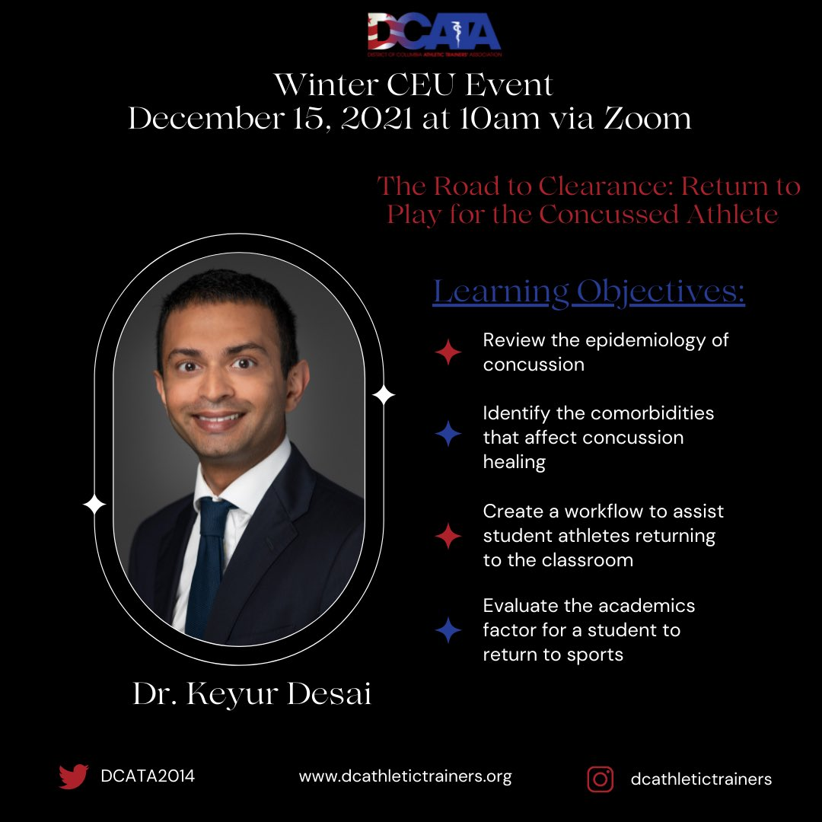
DCATA will be hosting our Winter Business Meeting and CE Event on December 15th at 10am via Zoom. Dr. Desai will present on “The Road to Clearance: Return to Play for the Concussed Athlete” at 10am and we will have a short business meeting following the CE presentation. This event is BOC approved for 1 Category A CEU. This event is free to all DCATA members and only $10 for non-DCATA members. You can register at
www.dcathletictrainers.org/events.

If you have any issues, you can contact Mike Walker at mwalker@stjohnschs.org.

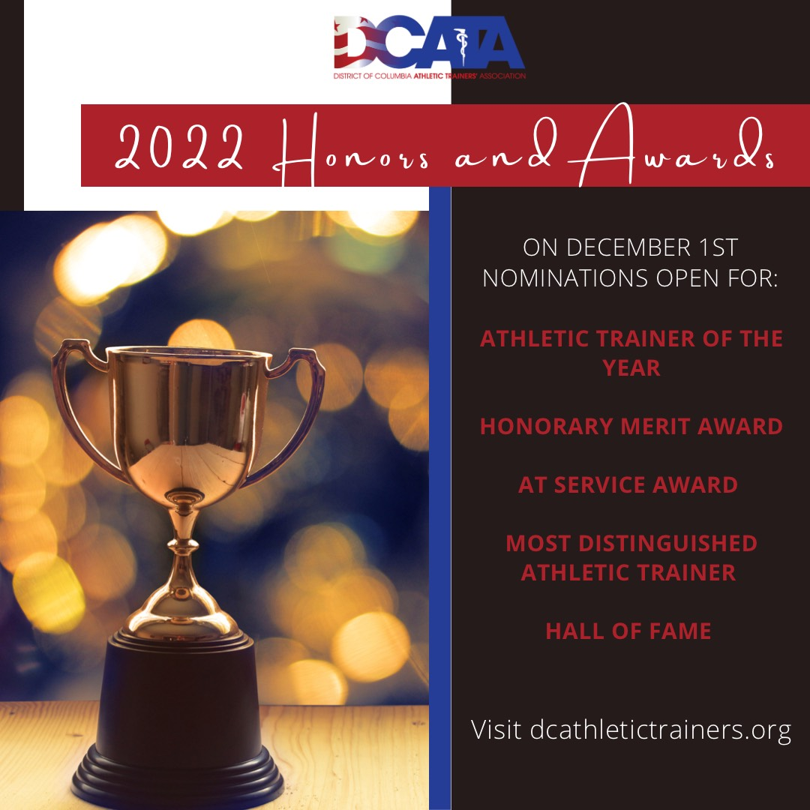
We are also excited to announce our 2022 Honors and Awards nominations are open NOW!
Click here to nominate a deserving colleague/ friend for one of our awards. Nominations will remain open until January 31, 2022.

WVATA
Zach Garrett
The WVATA annual meeting will tentatively be held April 8-10 in Morgantown. Those interested in submitting a proposal please contact Alison Hetrick at allison.hetrick@mail.wvu.edu. Submissions are due by December 15th.

