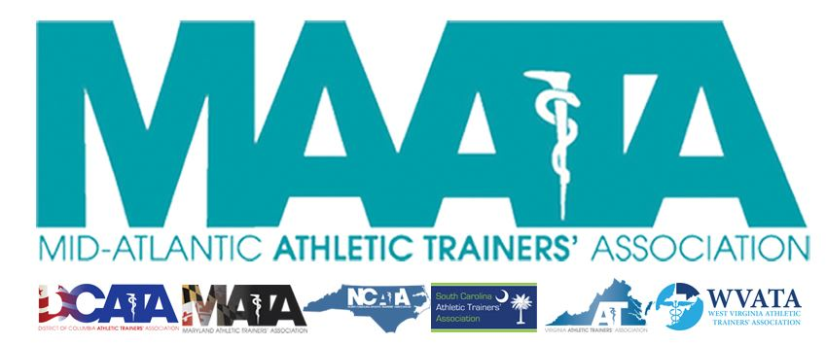

District Council Conference Call Minutes
January 18, 2023
8:30am

- Call to Order

  - President Cole called the meeting to order at approximately 8:30am.

- Roll Call:

  - Members Present:
    - Steve Cole – District President
    - Ray Davis – District Director
    - Donita Valentine – District Vice-President
    - Jason Mitchell – District Secretary
    - Mat Lyden – District Treasurer-Elect
    - Christina Carrillo – President, DCATA
    - Jean Perez – President, MATA
    - Nina Walker – President, NCATA
    - Will Christman – President-Elect, SCATA
    - Mike Kotelnicki – President-Elect, VATA
    - Tom Belmaggio – President, WVATA

  - Guests Present:

    - Marty Sataloff – District Parliamentarian
    - Jay Sedory – Past District Treasurer
    - Scott Cook – District Vice-President Elect
    - Erin Cash – District Secretary-Elect
    - Emily Hildebrand – Student Senate Faculty Advisor
    - Bob Casmus – Chair – Honors & Awards Committee

  - Members Absent:

    - Ray Davis – District Director
    - Amy Hand – President, SCATA
    - Danny Carroll – President, VATA
    - Zach Garrett – Chair - Educational Program Planning Committee
    - Katie Walsh Flanagan – Past District Director

- District Vice-President – Donita Valentine
  - Finalized program -14 CEs
  - Looking at opening registration next week

- District Treasurer & Past District Treasurer – Mat Lyden/Jay Sedory
  - End of year financial review
  - Introduction of new District Treasurer Mat Lyden

- MAATA Honors & Awards Committee – Bob Casmus
  - Announced 2023 MAATA award recipients
  - Reviewed nomination & selection process

- District Secretary – Jason Mitchell
  - National membership at a glance
  - District membership at a glance

- District President – Steve Cole
  - Old Business
    - Reviewed some additions from the proposed 2023 budget that was reviewed by the Executive Council on 12/12/2022

- State Presidents Reports:
  - District of Columbia – Christina Carrillo
    - 5th student AT symposium this March 11, sponsored by EDAC
    - Rock & Roll Race March 17 – bringing students to help with registration
    - Looking for speakers for the winter business meeting – first week in February
    - Working on meeting with the Board of Directors of the Board of Medicine to get back of the legislative agenda to continue working on finishing the licensure process

  - Maryland – Jean Perez
    - Lobby Day
      - Got to meet with highest number of elected officials during their breakfast
    - Official Symposium date – June 10
      - Looking at Towson University as the host site

  - North Carolina – Nina Walker
    - Planning state meeting - March 3-5
      - Adding suturing clinic within program
      - DEI workshop
    - NCATA leadership institute named incoming state class
      - Specialized programming to develop leadership skills

  - South Carolina – Will Christman
    - Licensure bill was seen by the Senate yesterday
    - Legislation Day is January 31 at the state house
    - Hosting high school workshop
      - 125 students registered
      - CE opportunities to those who bring students in
        - 32 total ATs attending

  - Virginia – Mike Kotelnicki
    - Education Symposium this past month, sponsored by Sentara Health
      - ~200 attendees
      - 7 colleges participated within AT Quiz Bowl
    - New bills dropping in Richmond this week
      - Includes wound closure, lidocaine admin, and emergency IV
      - 3rd-Party reimbursement with private insurance started January 1

  - West Virginia – Tom Belmaggio
    - Article published in the WV Times regarding a school district who wanted to hire 3 full-time ATs at high school levels, who could not find candidates, but then elected to allow the hire LPNs and other HCPs to those positions.
      - WV President & District Director Davis were quickly to respond, and WVATA is helping with assisting the hiring of ATs for these positions and how to move forward
    - Annual meeting set for March 25-26, in Charleston

- District Director – Ray Davis
  - NATA Updates
    - JCMs next week in Dallas
      - Includes BOD & committee chairs

    - NATA/MAATA advocacy
      - Please reach out to Amy Callender to assist with any initiatives

- District Vice-President Elect – Scott Cook
  - Working on getting registration up beginning of next week
  - Continuing to work with HelmsBriscoe on working on sites for future meetings

- Student Senate/Student Education Program – Emily Hildebrand
  - Professional & Student program updates
    - 5 sessions where students will be intermixed with professionals
    - Changing Mentor Breakfast to Saturday morning

- District President – Steve Cole
  - MAATA Updates
    - Proposed publication dates
    - Encouraged State Presidents to share the schedules for state correspondence, to help improve the membership messaging throughout the District
    - Governance task force updates

- Adjournment of meeting
  - Motion to adjourn meeting – Secretary Mitchell
    - 2nd – Director Davis
    - Approved 11-0-0
    - Meeting was adjourned 9:55 am

