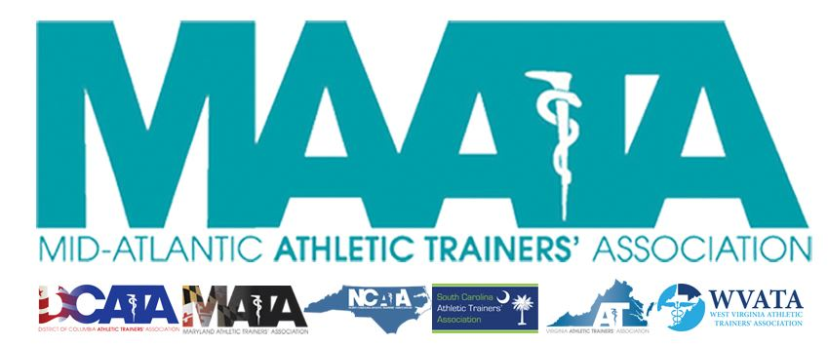

District Business Meeting Minutes
May 14, 2022
10:30am

- Call to Order
  - Director Flanagan called the meeting to order at approximately 10:30am.

- Approval of minutes of 2021 Business Meeting (5/15/2021)
  - Motion to approve – Bob Casmus
    - 2nd – Scott Johnson
    - Discussion
    - Motion passed (no opposed or abstention)

- Secretary Report – Jason Mitchell
  - Discussed District Membership data

- Treasurer Report – Jay Sedory
  - Discussed 2021 expenses/finances and upcoming budget
    - Discussed the creation of a Finance Advisory Council
    - Financially looking at a neutral or net loss for the year
      - Executive & District Council have addressed and have plans moving forward to correct in the future

- New Business – Director Flanagan
  - Governance Review – District Director-Elect Ray Davis
    - Creation of a task force to address the inclusion
      - Discuss timeline that has been approved by the Executive Council
  - Annual Meeting update – Vice-President Garrett
    - Discussed current registration numbers
    - Future Meeting Dates
      - May 17-19, 2023 – Founders Inn, Virginia Beach, VA
      - May 15-20, 2024 – Founders Inn, Virginia Beach, VA
  - Educational Program Committee – Zach Garrett
    - Reviewed submission process and reminding attendees how to obtain their CEUs
  - NATA Foundation – Jill Manners
  - Encouraged membership to access and read the District monthly Eblasts & Newsletters
    - Contains important information on how members can get involved and serve
  - NATA updates
    - DEI&A inclusion
      - Cultivate an inclusive environment & safe place
      - Provide program in ensure cultural competency
      - Increase transparency and keeping other accountable
      - Support and intentionally promoting the Athletic Training profession
    - NATA Professional Values
      - Caring & Compassion
    - NATA proposal of membership dues increase
      - Proposal to decide on an up-to $30 membership dues increase
        - Please look over the online presentation from NATA president Dieringer
        - Please access our MAATA website to please give your feedback so the acting District Director can accurately represent District 3
    - 2022 NATA Annual Meeting – Philadelphia, PA
      - June 28 - July 1

- MAATA Committee Report
  - EDAC – Xavion Santiago
    - Thanks for members who attended EDAC presentation last night
    - BE the Match Drive
    - RISE event
    - ATs in Action photos needed
    - Currently looking to fill the WV state representative position
  - Secondary School - Adam Wall
    - Establishment of new committee with all state representatives
    - Safe Sports Awards
  - Young Professionals Committee – Kelsey Riley & Cassie Mosely
    - Please come out to our YP social tonight
  - Student Senate – Renee Adamonis
    - Reviewed structure & makeup of the Senate
    - Please take a look at the monthly newsletters
    - Selling MAATA hats/t-shirts/towels
      - All funds will be going to a selected under-funded AT

- NATA Committee Report Young Professionals Committee – Kelsey Riley
  - NATA Foundation – Marty Baker
    - Sold out event at Annual Meeting in Philadelphia
    - Please continue to financially support the Foundation
      - Amazon smiles
      - Circle of Champions
  - ATs Care – Alice McLaine
    - Remarkably busy of the last 2 years
    - Designed to provide peer-to-peer counseling
    - Reviewed cases for the 2021 calendar year
  - Young Professionals Committee –Cassie Mosely
    - Career Advancement Committee (7-12 years of Certification)
      - Established r5 DEI Commitments and Initiatives
      - National Distinguished Award
      - DEIA event in Philadelphia
        - June 29 (11:05-12pm)
  - Connection & Engagement Committee – Jenni Johnson
    - Goal of this new committee to increase membership and initiatives to increase membership retention
    - NATA Virtual Event
      - May 22 @ 7pm CDT
    - Developing a Welcome Packet for brand new members
  - Convention Program Committee – Michael Higgins
    - Review makeup of the programming at the NATA Annual Meeting in Philadelphia
    - Encourage members to submit materials for future programming
  - EDAC – Xavion Santiago
    - Events in Philadelphia
      - Day of Service – June 28
      - Town Hall – June 29 4-6pm
      - Educational Session – June 30 10:20-11:15am
      - Student Career Day – virtual (post-convention)
  - Early Professionals Committee – Kelsey Riley
    - New committee composed for members 0-6 years of Certification
    - EPC/SLC/COPA Webinar Series
    - GAC/EPC Membership committee
  - Professional Education Committee – Ashley Thrasher
    - Support program directors/educators/preceptors
    - Master Preceptor – Level 3 programming is coming soon
    - Chat Series – For preceptors provided by preceptors
    - AT Teaching Tips
      - Please provide 7–10-minute model practices if there are any unique tips/techniques/etc.
  - Secondary School - Adam Wall
    - DEIA initiatives
    - ATLAS program – please submit & update your information
    - NATA Safe Sports Award Grant
    - SSATC session in Philadelphia
      - Friday July 1 – 7:30-8:25am

- Awards
  - MAATA Honors & Awards session
    - Today @ 4pm
    - Hall of Fame/Most Distinguished/Service Awards
    - Scholarship
    - Korey Stringer Life Savers Award
    - ICSM New Horizon Awards

- Other News
  - Point of Order - Past Director Aronson
    - Special thanks to Director Flanagan for her service
    - A District tradition is one of the final acts of the Past Director position is to present a gift to the exiting current Director at their final District business meeting

- Adjournment – Director Flanagan
  - Motion – John Bielawski
    - 2nd – Pat Lamboni
    - Meeting was adjourned 12:10pm

