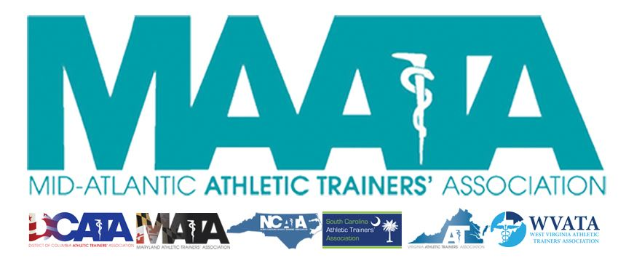

District Council Conference Call Minutes
February 11, 2019
10:00am

- Call to Order

  - Director Flanagan called the meeting to order at approximately 10am.

- Roll Call:

  - Members Present:
    - Katie Walsh Flanagan – District Director
    - Jason Mitchell – District Secretary
    - Sean Dash – President, DCATA
    - Wes Robinson – President, MATA
    - Jim Bazluki – President, NCATA
    - Brad Drake – President, SCATA
    - Scott Powers – President, VATA
    - Jenni Johnson – President, WVATA

  - Guests Present:

    - Marty Sataloff –District Parliamentarian
    - Nick Saul – NATA Student Leadership Committee, D3 representative

  - Members and Guests Absent:

    - Ray Davis – District Treasurer
    - Patricia Aronson – Past District Director

- NATA Updates:

  - NPI (National Provider Identifier) – doing a big push to be counted. Upcoming campaign with the Alliance (BOC/CAATE) to increase our AT numbers
  - Capitol Hill Day
    - Registration closes Feb 28 - please register and have your voices heard
  - ATsCare
    - In latest Newsletter, the state of Delaware issued an invitation to their training session for 1st portion of ATsCare
      - ATs interested in participating need to complete this training prior to applying.
      - ATs must go through official NATA application process to officially be an ATsCare representative.
    - D3 is one of the first Districts to have representatives in every state!
  - National Athletic Training Month coming up soon
    - ATs are Health Care
  - National News
    - Protecting Young Victims from Sexual Abuse Act
      - Passed into law last year
      - Extends the duty to report onto ATs
        - Strongly encourage review NATA paper discussing duties to report
  - NATA award winners
    - Go to your state database and congratulate your award winners!
    - Jason Mitchell – current database is still being updated with current winners but will be plugged into state DropBox once available.
  - NATA has partnership with Mercer Insurance to protect ATs who provide PRN services.
    - Go4Ellis is increasing its outreach to provide PRN opportunities to ATs.
  - Korey Stringer Institute
    - Still working with ATLAS
      - Please encourage members to continually update their information
      - D3 is currently 68% mapped
    - Hosting State Forums – discussing State practice/safety acts
      - State Presidents & District Directors are to be invited to these meetings to update their constituents
    - Have monies available to Faculty and/or Preceptor for education grants (~$1000)
      - Check areas & availability to take advantage!

- District 3 Updates:

  - Presidents – submit materials to the Spring Newsletter
  - July – will be publishing an Honors & Awards edition newsletter
    - Please submit photos of all award recipients
  - MAATA committees – Board Liaisons
    - Each District committee has a liaison to the District Council
      - Committee chairs are charged with including their liaison on all details/meetings/correspondence
    - Educational Program Committee – Wes Robinson
    - Governmental Affairs Committee – Jenni Johnson
    - Honors & Awards Committee – Sean Dash
    - Annual Meeting Planning Committee – Ray Davis
    - Public Relations Committee – Jason Mitchell
    - Research & Grant Committee – Scott Powers
    - Secondary Schools Committee – Jim Bazluki
    - Scholarship Committee – Katie Walsh Flanagan
    - Young Professional Committee – Brad Drake
  - State Fact Sheets placed within the MAATA website
    - Brings powerful info in the push to advocate for AT
  - GLATA coming to D3 meeting
    - Will speak at our Business meeting regarding their plans to subdivide into 2 separate districts.
    - Currently held at NATA BOD for final approval, but will present to each of the Districts to help transparency.

- State Presidents Updates:
  - District of Columbia – Sean Dash
    - Student Symposium (geared mostly to high schools)
      - March
      - Sponsored by DC EDAC
    - Half way thru 60-day Congressional review period of Bill for Licensure/Practice Acts

  - Maryland – Wes Robinson
    - Governmental Affairs
      - Large amount of turnover in Annapolis this year
        - Taking time this year to education the new people about AT to then make big legislative pushed for next year
      - Positive meetings with Board of Physicians this past summer
        - Making some changes to the Opening Settings & AT advisory Committee
        - Board of Physicians showed great support in proposed changes
      - Lobby Day - March 19
    - Legislation from Acupuncture Group
      - Potentially taking Dry Needling away from ATs

  - North Carolina – Jim Bazluki
    - Annual Spring Meeting
      - March 8-10, Concord, NC
    - Legislative Meet & Greet – April
    - Planning big push for NATM – hoping for 3rd consecutive national PR award!

  - South Carolina – Brad Drake
    - College/University Symposium & High School workshop scheduled next week
    - SC Hit-the-Hill day
      - ~200 people in attendance (~25 legislators)
      - Introduced Bill to update the language of practice act
    - NATM 5k event
      - Proceeds going to SC scholarships

  - Virginia – Scott Powers
    - 2nd annual Secondary Schools meeting this past December
    - VA Hit-the-Hill day
      - 60-70 in attendance
      - Passed bill updating Concussion law
        - Allows ATs to edit the law as EBP updates, without going through full legislative process
      - Have several town hall meetings scheduled throughout the state

  - West Virginia – Jenni Johnson
    - Licensure Bill voted out of the Health Committee onto Senate floor
      - Confident in passage in the next few days
    - WV state meeting upcoming in March

- Guest Updates
  - Nick Saul
    - Promoting NATA student initiative
      - NATM video contest
      - NPI initiative contest
      - Chuck Kimmel first-time-attendee award

- Final Announcements/Comments
  - Annual Business Meeting will now be on the Friday schedule of our MAATA meeting.
  - Secretary Mitchell
    - Initiatives to push the last-minute NATA membership renewals
      - Currently, D3 renewals looking good
- Director Flanagan adjourned the meeting at 10:42am.

