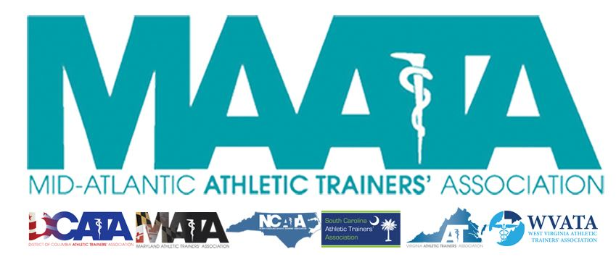

District Council Meeting Minutes
May 17, 2019
11:00am

- Call to Order
  - Director Flanagan called the meeting to order at approximately 11am.
- Roll Call:
  - Members Present:
    - Katie Walsh Flanagan – District Director
    - Jason Mitchell – District Secretary
    - Ray Davis – District Treasurer
    - Pat Aronson – Past District Director
    - Sean Dash – President, DCATA
    - Wes Robinson – President, MATA
    - Jim Bazluki – President, NCATA
    - Brad Drake – President, SCATA
    - Scott Powers – President, VATA
    - Zach Garrett – President-Elect, WVATA (present via telephone communication)
    - Mary Catherine Avery – Student Senate President
    - Marty Sataloff –District Parliamentarian
  - Guests Present:
    - Scott Cook – Annual Meeting Planner
    - Kim Pritchard – Educational Program Chair
    - John Knaul – Exhibits Coordinator
    - David Gallegos – NATA District 7 Director
    - Lyn Nakagawa – NATA District 8 Director
    - John Bielawski – Memorial Resolutions
    - Pat Lamboni – Social Chair
    - Donita Valentine – ATs Care
    - Craig Voll – NATA District 4 Director
- MAATA Meeting update:
  - Scott Cook – Annual Meeting Planner
    - Provided registration data and overview of events to the DC
    - Director Flanagan discussed safety regulations with OC Cruisin’ Weekend
  - Kim Pritchard – Educational Programming Update
    - Introduced herself to committee
    - Discussed the operations of the Educational Planning Committee
      - 5 EBPs/8 Category CEUs offered in General Sessions
  - John Knaul – Exhibits update
    - 17 Exhibitors/Sponsors
      - ~$11500 income
    - Events:
      - Exhibitor’s Reception – Friday evening
      - Coffee w/ Katie – Saturday morning
  - Student Symposium Update – Mary Catherine Avery
    - Discussed committee breakdowns & events
      - Friday:
        - Student Meet & Greet/Bingo
      - Saturday
        - Integration of Position Statements into Clinical Practice
      - Sunday
        - Mentor’s Breakfast
        - Networking/Career Building
  - Pat Lamboni – Social Chair
    - Discussed social events for the Annual Meeting
- Secretary Report – Jason Mitchell
  - Discussed District Membership data
    - Director Flanagan discussed new member benefit with allowing a mechanism to publish IRB-approved surveys out to the membership database.
    - Motion to approve Secretary’s report – Scott Powers
      - 2nd – Sean Dash
      - No discussion
      - Passed – 9-0-0
- Treasurer Report – Ray Davis
  - Discussed 2019 expenses/finances and upcoming budget
    - Motion to approve Treasurer’s report – Scott Powers
      - 2nd – Jim Bazluki
      - No discussion
      - Passed – 9-0-0
- MAATA Updates
  - Elections – Pat Aronson
    - Discussed upcoming elections in November 2019
      - Elected District Director (if not Director Flanagan) and District Treasurer will shadow current officer until their term starts in June 2020.
      - Elected District Secretary (if not Secretary Mitchell) will begin immediately in November 2019
        - Executive Council has voted to keep Secretary Mitchell as District Secretary from June-November 2019.
  - By-Laws updates – Katie Walsh Flanagan
    - Section 5.3 of By-Laws & Article 10.1 of Constitution
      - There is currently an incongruence in the language
      - Discussed process of candidate selection to committees
      - This will be addressed and up for vote in tonight’s Business Meeting
    - Announced that NATA District IV Director Craig Voll will be presenting the restructuring of their District to our District Meeting
      - Director Voll came in later in the meeting to discuss further about the proposed re-districting of District IV in two Districts (IV & XI) and answer questions.
- Lunch Break @ 11:46am/Meeting resumed @ 11:55am
- MAATA Committee Reports
  - Scholarship Committee Chair Replacement – Katie Walsh Flanagan
  - Review of Annual Reports
- NATA Committee
  - ATs Care Update
    - Over 16,000 ATs affected by situations in the U.S.
      - 23 incidents in D3
    - Discussed proper procedures/chain-of-command in becoming a representative of ATs Care
    - All interested in serving on a state ATs Care committee should apply via the instructions on the MAATA.org web page and submit materials to the Secretary Mitchell
    - Donita Valentine came in later in the meeting to continue discussions of ATs Care structure and took questions regarding specific state scenarios
- MAATA Updates cont.
  - Memorial Resolutions – John Bielawski
    - Asked State Presidents to appoint State Representatives to assist collect data
    - Art Contest
      - The winner’s artwork will be placed within all publications
- State Presidents’ Reports
  - District of Columbia – President Sean Dash
    - Discussed new officers
    - Licensure was signed into law April 11
      - April 24 Board of Medicine passed regulation
      - Goes out for Publication/Review for 30days, and still awaiting it to be published
    - DC awarded Dan Campbell Legislative award
  - Maryland – President Web Robinson
    - Welcome to Maryland for the D3 meeting!
    - Legislatively quiet since combination of large number of new legislators and busy previous year.
    - Posed question to Council regarding CVent use for State meetings
      - Will send out MD proposal to rest of Council to see cost savings with combined usage.
  - North Carolina – President Jim Bazluki
    - President/Secretary elections this fall
    - Waiting to hear from NATA on state legislative PR award to see if they would be awarded a 4th consecutive year
    - Proposed being able to bring NCATA PR Art Exhibit to District & State Meetings
  - South Carolina - President Brad Drake
    - Discussed proposals/changes with SC positions/elections/changes
    - Introduced a bill to update language in state regulations in February
      - Signed into law yesterday
      - Can lead the way to start changing state practice acts
    - Early stage planning to move towards State Licensure
    - Completed 1st Virtual 5K
      - 123 participants/raised over $2000 for scholarships
    - Discussed programming with upcoming SC State Meeting/Symposium
  - Virginia – President Scott Powers
    - Discussed Annual Meeting in January and inclement weather
      - Discussed new location for future VA Annual Meetings
    - Hit the Hill Day
      - Over 50 people in attendance
      - Continued progress with language in state regulations
    - Student Scholarship Program
      - Named after past president Tom Jones
    - Discussed beginning process/surveys with 3rd-Party reimbursement
    - 2nd Annual Secondary Schools Symposium
    - Discussed upcoming officer elections
  - West Virginia – President-Elect Zach Garrett
    - Call Dropped
- Student Senate Report – Mary Katherine Avery
  - Encouraged states to contribute to their periodic publications to promote students
  - Service Project
    - Raising funds for ATs who can benefit to improve their AT environment
      - Penny Wars/Accepting donations
  - Discussed efforts to create/put on the Student Symposium
- Additional news/updates?
  - Director Flanagan
    - Initial discussions on implementation of a District President to the Executive Council
    - DC meeting at NATA Las Vegas Tuesday, June 25 @ 1:30pm
      - Location: TBD
    - District Business at NATA Las Vegas Tuesday, June 25 @ 5:30pm.
      - Location: TBD
- Motion to adjourn – Sean Dash
  - 2nd – Scott Powers
  - No Discussion
  - Director Flanagan adjourned the meeting at 1:30pm

