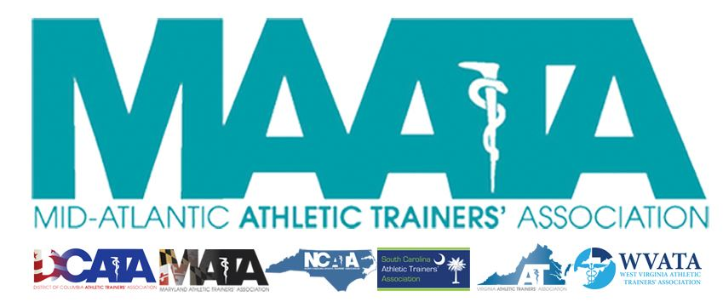

District Council Conference Call Minutes
January 28, 2020
8:00am

- Call to Order

  - Director Flanagan called the meeting to order at approximately 8am.

- Roll Call:

  - Members Present:
    - Katie Walsh Flanagan – District Director
    - Ray Davis – District Treasurer
    - Jason Mitchell – District Secretary
    - Patricia Aronson – Past District Director
    - Michael Walker – President, DCATA
    - Wes Robinson – President, MATA
    - Jim Bazluki – President, NCATA
    - Brad Drake – President, SCATA
    - Chris Jones – President, VATA
    - Jenni Johnson – President, WVATA

  - Guests Present:

    - Marty Sataloff –District Parliamentarian
    - Emily Hildebrand – Student Senate Advisor

  - Members and Guests Absent:

    - Jay Sedory – District Treasurer-Elect

- MAATA Updates:
  - Update on Task Force to investigate MAATA governance structure
    - Potentials for adding a District President & Vice-President
    - Nancy Burke lead Task Force since November
      - Sent potential constitution & by-law changes if a President/Vice-President were added
      - Executive Council will review
      - District Council will receive updates in late February/early March
        - If approved, it will be presented to membership at Annual Meeting in May
        - Intention to putting new officer(s) in office Fall 2020
  - NATA President – Tory Lindley very complimentary regarding his recent conversations with State Presidents
  - Encouraged States to send photos of all award winners for our July newsletter

- NATA Updates:
  - 5 members earned national awards
    - Encouraged states to continue looking at their membership to push nominations
  - BOC – Professional goals
    - Offering 10 CEUs ($65) to be a volunteer for this pilot program
  - NATA Presidential Nomination Committee
    - Released finalists for upcoming NATA President election
      - Kathy Dieringer & our own D3 Director Katie Flanagan
    - Large social media push to allow Districts & States to distribute candidate information
  - National Hit-the-Hill Day - May 13-14
    - NATA BOD meeting in TX on May 17th
    - Many BOD members may be in attendance at our District Meeting

- State Presidents Updates:
  - District of Columbia – Michael Walker
    - Made contact with the licensing Executive Director regarding the practice act
      - Working close with Board of Medicine to get closer towards licensure
    - State Meeting
      - Initiating conversation with State Exec Board on potential to connect meeting with the student symposium

  - Maryland – Wes Robinson
    - Legislative push
      - 90 days period for completion
        - Started January 8
      - Upcoming meeting with State Delegate Young, MD APTA, MD OTA to address any concerns
      - 17 co-sponsors
    - Recently sent out I-Petition to support the MD bill
    - Just completed officer elections
      - Jean Perez – Vice-President
      - Ashley Holmes – Secretary
      - Amber Kelso - Treasurer
    - Working with EMS to change protocols to “Cool 1st/Transport 2nd”
      - 100% approval
      - Tie in public announcement during Lobby Day – Feb. 25 – Annapolis, MD
    - State Meeting - May 30 – Towson, MD

  - North Carolina – Jim Bazluki
    - State Meeting – March 6-8 – Wrightsville Beach, NC
      - 14.5 CEUs (6.5 EBPs)
      - Offering in-state rates for neighboring state attendees

  - South Carolina – Brad Drake
    - Hit-the-Hill Day: Feb 12
      - Licensure task force progressing
    - Officer elections this May
    - State Meeting – July 8-10
    - Updated language to practice acts
      - Updates of state regulations in process
        - Projected finalized mid-2021

  - Virginia – Chris Jones
    - State meeting this past Jan 3-5 in Harrisonburg, VA
      - 175 ATs/90 students
    - Hit-the Hill day yesterday (Jan 27) – 3 bills updates
      - HB 59
        - Add LAT to insurance code to allow 3rd party reimbursement
        - Referred for further review/study to House Labor & Commerce Committee
      - HB 1261
        - Allow LAT to carry naloxone & other opioid antagonist
        - Read twice in House, with 1 more reading prior to vote
          - All feedback is positive that this will pass
      - HB 1260
        - Advisory Board on Athletic Training
          - Adjusting language to permit ATs in public & private sectors the opportunity to serve on the board
    - Task Force working on association management services
    - VATA utilizes a AT member with financial management experience to increase investing opportunities
      - Significantly increased annual earnings
        - This has allowed decreased costs to membership to their state meeting
      - Director Flanagan encouraged States to look into similar services to see how it could benefit their respective associations and membership

  - West Virginia – Jenni Johnson
    - Officially licensed as of January 1
      - Currently following 9 bills related to Secondary Schools athletics & sports safety
        - Introduced Alex Miller Law
          - Requires AED present for all athletic activities
            - Medical staff must be trained
        - Introduced law requiring all schools, that participate in athletics, employ a “full-time Athletic Trainer or Medical Professional”
          - Working to change the “Medical Professional” to eliminate ambiguity
    - Capitol Hill Day & Korey Stringer event - Feb 13-14
    - State Meeting - April 3-4 – Morgantown, WV
      - Offering in-state rates for District state attendees

- District Treasurer – Ray Davis
    - Will send the DC a proposal to amend budget, that was approved last May, for electronic vote

- Guest Updates
  - Student Senate - Emily Hildebrand
    - Encourage states to keep student senator representatives updated on any state news to include in Student Senate newsletters

- Approval of minutes of District Council Meeting – Conference Call (10/16/2019) – Jason Mitchell
  - Motion to approve – Wes Robinson
    - 2nd – Jim Bazluki
    - Passed – 9-0-0
- Final Announcements/Comments
  - Secretary Mitchell encouraged states to continue push for NATA membership renewals
    - Deadline January 31
- Director Flanagan adjourned the meeting at 8:45am.

