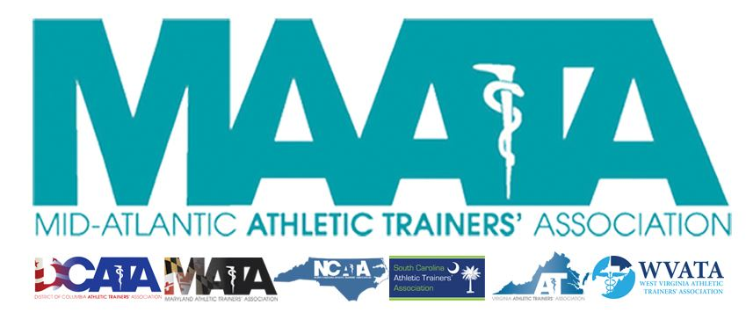

District Council Meeting Minutes
June 25, 2019
1:30pm

- Call to Order
  - Director Flanagan called the meeting to order at approximately 1:30pm.
- Roll Call:
  - Members Present:
    - Katie Walsh Flanagan – District Director
    - Jason Mitchell – District Secretary
    - Ray Davis – District Treasurer
    - Pat Aronson – Past District Director
    - Mike Walker – President, DCATA
    - Gina Palermo – Vice-President, MATA
    - Jim Bazluki – President, NCATA
    - Brad Drake – President, SCATA
    - Scott Powers – President, VATA
    - Jenni Johnson – President, WVATA
  - Guests Present:
    - Mark White – NATAPAC representative
  - Guests Absent:
    - Mary Catherine Avery – Student Senate President
    - Marty Sataloff –District Parliamentarian
- Approval of minutes of District Council Meeting in Ocean City, MD (05/17/2019) – Jason Mitchell
  - Motion to approve – Jim Bazluki
    - 2nd – Scott Powers
    - Passed – 9-0-0
- Treasurer Report – Ray Davis
  - Discussed final expenses/finances for just passed fiscal year and upcoming budget
    - Motion to amend approved 2019 Budget – Scott Powers
      - 2nd – Jenni Johnson
      - Pat Aronson inquired of financial status of the 2019 Annual Meeting
      - Passed – 9-0-0
- NATA BOD Updates – Katie Walsh Flanagan
  - Updates from BOD meetings in Chicago (May) & this past weekend (June 23 – Las Vegas)
    - NCAA/NATA press release
    - State updates
      - 3rd-Party reimbursement
    - Fair practice workgroup
    - PASS (Secondary Schools Committee) – Program Assessment for Safety in Sport
    - Sidelined USA
      - For sidelined athletes (partnership with NATA)
      - Resources available online
  - Circled back to GLATA restructuring
    - District Council unanimously in favor
- MAATA Structure discussion
  - Director Flanagan distributed handout of NATA data on Districts with Presidents
    - Discussed investigating the implementation of additional officers (e.g. President, Vice-President, etc.)
    - Executive Council agreed to pursue forming a task force to explore District 3 options for new & existing officer position restructuring
      - No opposition from District Council
- State President Reports & Discussion with NATAPAC – Mark White
  - DC – Michael Walker
    - Discussed progress with limiting AT regulations
      - Finally passed amendments changes this past December
        - Biggest change was change in Supervisory board
          - Transition from PT board to DC Board of Medicine
        - Developing Practice Act with PT Board
          - Currently being processed by Board of Medicine
    - Volunteerism
      - Rock & Roll Marathon in February
      - Student AT Symposium – funded by EDAC
      - Established Student AT Club
        - Meet every other month to discuss various AT/Sports Medicine topics
  - WV – Jenni Johnson
    - Implemented 2 Bills
      - Secondary Schools & Licensure
    - Currently under the PT board
      - Beginning process to create an AT-only Board
  - MD – Gina Palermo
    - Nothing to report
  - SC – Brad Drake
    - Presented bill last March updating language of the current law
      - Passed in May
    - Currently still Registration status
      - Starting preliminary talks to strategize towards Licensure
    - Upcoming SC State Symposium
  - VA – Scott Powers
    - Working with State PT Association in addressing AT Practice Act
    - Co-presenting public concussion panel discussion presentation for State PT
  - NC – Jim Bazluki
    - Shout out to SC for getting NC dance art project displayed at their state meeting
  - NATAPAC update – Mark White
    - 307 people from D3 signed up for NATAPAC Breakfast
      - SOLD OUT EVENT
    - Continue working on reaching out to new contributors & new initiatives
    - Reviewed distributed funds for 2018/2019
    - Hit the Hill Day
    - D9 hosted a NATAPAC breakfast with Chuck Kimmel as lead speaker
      - Encourage District Council to incorporate something similar to the MAATA Annual Symposium
- Additional news/updates?
  - Updates from DST – Jason Mitchell
    - New Leadership Orientation
      - Create consolidated materials for District & State Leadership to provide to their new/upcoming leaders
    - Reviewing best practice acts regarding Membership Data distribution
    - Reviewed NATA policy regarding proper use of distribution of logo materials
- Motion to adjourn – Scott Powers
  - 2nd – Gina Palermo
  - No Discussion
  - Director Flanagan adjourned the meeting at 2:59pm

