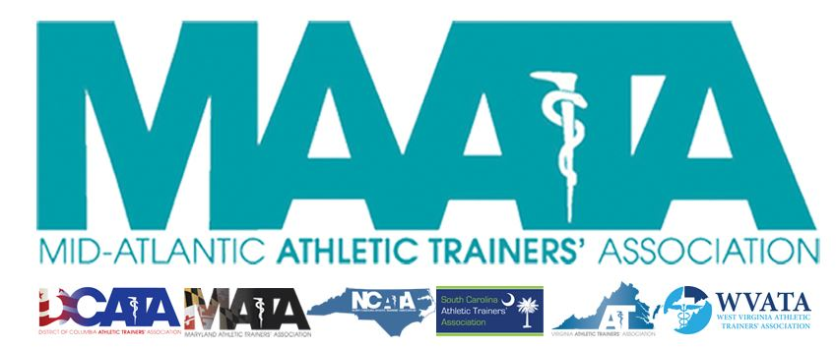

District Council Conference Call Minutes
November 16, 2022
8:30am

- Call to Order

  - President Cole called the meeting to order at approximately 8:30am.

- Roll Call:

  - Members Present:
    - Steve Cole – District President
    - Ray Davis – District Director
    - Donita Valentine – District Vice-President
    - Erin Cash – District Secretary-Elect
    - Jay Sedory – District Treasurer (logged into meeting @ 9:24am)
    - Katie Walsh Flanagan – Past District Director
    - Christina Carrillo – President, DCATA
    - Jean Perez – President, MATA
    - Nina Walker – President, NCATA
    - Amy Hand – President, SCATA
    - Danny Carroll – President, VATA

  - Guests Present:

    - Marty Sataloff – District Parliamentarian
    - Bonnie Van Lunen – Chair, MAATA Research & Grants Committee
    - Emily Hildebrand – Student Senate Faculty Advisor
    - Scott Cook – District Vice-President Elect

  - Members Absent:

    - Jason Mitchell – District Secretary
    - Tom Belmaggio – President, WVATA

- District Secretary-Elect – Erin Cash
  - Approval of minutes of previous District Council Meeting – (10/19/2022)
    - Motion to approve – VA President Carroll
      - 2nd – Vice-President Valentine
      - No discussion
    - Passed – 10-0-0

- Special Reports – Bonnie Van Lunen
  - Reviewed R&G Committee proposals process
    - 4 total proposals for this year ($3000 total funds)
      - Awarded 3
      - $735 – project in finding affordable dynamometer for clinical measures in quadriceps strength in ACL reconstructed knees
      - $600 – examination of perceptual functioning in Pts with post-ACL reconstruction
      - $1665 - association between CNS function and core body temp in exertional heat stroke patients
    - Discussed future committee meetings, proposing potentially increase the amount of annual funds awarded
    - Pathway of updating the system, with attempting to aligning with the process of the Foundation with documentation submission & scoring
  - President Cole addressed the need to send funds to recipients in a time-sensitive manner
    - Request motion to approve the immediate dissemination of the budgeted $3000 for R&G committee grant recipients
    - Motion to approve – Director Davis
      - 2nd – Secretary-Elect Cash
      - Need to receive confirmation if these funds will be coming out of the 2022 or 2023 budget
      - Passed – 10-0-0

- District Director – Ray Davis
  - National Updates
    - Continue to use gATher with all national volunteer applications
    - Upcoming BOD meeting this upcoming Monday
      - Will be discussion how the strategic plan with be rolled out
      - Budget discussions
    - Working on getting NATA President involved in our D3 Annual Meeting
    - Continue to encourage that states work with the NATA GAC boot camps, which is a great member benefit
    - Continue to promote members to apply for volunteer positions
      - Several positions are open/available nationally, so member opportunities are there!

- State Presidents Reports:
  - District of Columbia – Christina Carrillo
    - Planning on quarterly CE event
    - Planning student AT symposium
    - DC Sports Medicine AC meeting in December to push some items that KSI thought they could improve on

  - Maryland – Jean Perez
    - Still working on nailing down dates for state annual meeting
    - DEI committee is trying to plan a panel discussion around transgendered athletes

  - North Carolina – Nina Walker
    - Recently had great DEI talk for Native American Month which will be posted on the state website
    - General assembly, working on some current NC laws to ensure maintenance of state licensure and ensure quality patient care
    - Leadership Brunch @ High Point on Dec. 5 – great opportunity to get state leadership in front of each other

  - South Carolina – Amy Hand
    - Recently sent out the dates for the state annual symposium – July 12-14, 2023
      - Also sent out the call from proposals
    - Restructuring Annual Symposium Planning Committee
    - Officially hired new lobbyist, and they have started
      - Drafted a bill to go in January to change state certification to license
        - Have already received a Senate sponsor for this bill, and currently in search for a House sponsor

  - Virginia – Danny Carroll
    - Finalizing plans for state annual meeting – Jan 13-15 in Harrisonburg
    - DEI committee had reached out to address specific language from Governor’s office regarding trans student which they thought was concerning
    - VATA & ATs Care have reached out to the staff at UVA regarding the recent tragic shootings to ensure they have the resources they need.

- Student Senate Updates – Emily Hildebrand
  - Continue to work with committees & subcommittees to connect the Student Senate rep to their respective committee chairs
  - Will be updating website to have current Senate contact information

- Other Committee Updates: Katie Walsh Flanagan
  - Student Scholarship Committee
    - Named Sara Pittelkau as chair
    - Missing representatives for DC, NC, & WV
    - Working on updating the current criteria for scholarships to match updated education standards
  - ATsCare
    - Looking to setup group session to assist UVA AT staff & 20 AT students
    - Need 2 ATsCare group-session representatives to come in to accommodate this
      - Requesting use of budgeted ATsCare line item to send 2 ATsCare group-session representative, which is totals $2000
      - Motion to approve – VA President Carroll
        - 2nd – MD President Perez
        - Discussion
        - Passed 10-0-0

- District Vice-President – Donita Valentine
  - Annual Meeting update
    - May 19-21, 2022 @ Founder’s Inn in Virginia Beach, VA
    - Call for Proposals is still going on (deadline Dec. 9)
    - Opening registration in early January

- District Treasurer – Jay Sedory
  - Financial update
    - Reviewed all the collected budgetary requests to assist creating 2023
    - Reviewed the financial details for projected budget line-items for the upcoming Annual Symposium
    - Provided DC with the Finance Committee recommendation for the 2023 budget of $102,707.79
      - Motion to approve – Treasurer Sedory
        - 2nd – Vice-President Valentine
        - Discussion
          - Director Davis stated that since this is the first time this proposed 2023 budget was presented to the group, that this should be tabled to then provide the group with more information on the individual line-items to justify the numbers.
        - Treasurer Sedory moved to table the motion to approve the 2023 budget
          - Approved – President Cole
            - 2nd - Director Davis
            - Motion was tabled – 10-0-0

- District President – Steve Cole
  - MAATA Updates
    - Expectations as a Committee Liaison
    - Call for Proposals for Educational program
    - Membership renewal
      - D3 Day – December 3
    - Governance Task Force
    - Encouraging state involvement in filling committee vacancies & appointments

- Adjournment of meeting
  - Motion to adjourn meeting – Treasurer Sedory
    - 2nd – Director Davis
    - Approved 10-0-0
    - Meeting was adjourned 10:30 am.

