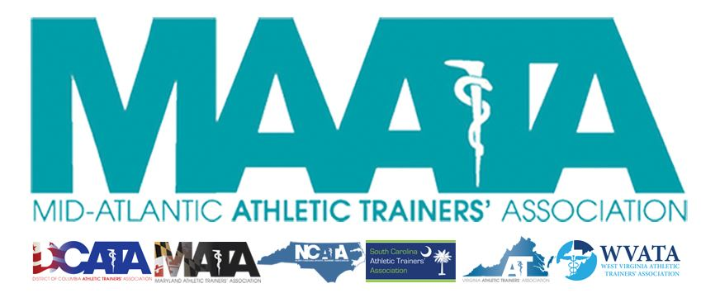

District Council Conference Call Minutes
February 16, 2023
8:30am

- Call to Order

  - President Cole called the meeting to order at approximately 8:33am

- Roll Call:

  - Members Present:
    - Steve Cole – District President
    - Ray Davis – District Director
    - Donita Valentine – District Vice-President
    - Erin Cash – District Secretary-Elect
    - Mat Lyden – District Treasurer
    - Christina Carrillo – President, DCATA
    - Jean Perez – President, MATA
    - Meredith Petschauer – NCATA VP
    - Amy Hand – President, SCATA
    - Danny Carroll – President, VATA
    - Tom Belmaggio – President, WVATA

  - Guests Present:

    - Marty Sataloff – District Parliamentarian
    - Katie Walsh Flanagan – Past District Director
    - Scott Cook – District Vice-President Elect
    - Emily Hildebrand – Student Senate Faculty Advisor
    - Kirk Armstrong – LBGTQ+ Committee Chair
    - Mike Kotelnicki – President-Elect, VATA

  - Members Absent:
    - Jason Mitchell – District Secretary
    - Nina Walker – President, NCATA

- District Secretary – Erin Cash
  - Approval of minutes of previous District Council Meeting – (12/14/2022)
    - Motion to approve – WV President Tom Belmaggio
      - 2nd – District Vice President Donita Valentine
      - No discussion
    - Passed – 11-0-0
  - Approval of minutes of previous District Council Meeting – (1/18/2023)
    - Motion to approve – VATA President Danny Carrol
      - 2nd – DCATA President Christina Carrillo
      - No discussion
    - Passed – 11-0-0

- District Vice-President – Donita Valentine
  - Registration is open for MAATA Annual Meeting
    - 14 Cat A CEU’s
    - Graston, Casting & Graston Orthotics being offered
    - 5 Learning Labs
    - Mugs given at Registration
    - Pushing for $6.75/month donation – Aiming for $75/year (that would be $6.25/month)
    - NATA President Dieringer will be discussing BOC/CAATE (virtual)

- District Vice-President Elect – Scott Cook
    - $6,500 in Sponsors
    - 43 Total

- District Director – Ray Davis
    - Open Volunteer NATA Positions on GATHER
    - Scholarships are open, Bobby Gunn Scholarship for District 3
    - Please submit for April’s MAATA Newsletter

- Past District Director – Katie Walsh Flanagan
  - Going to push the Annual Meeting on Social Media
  - MAATA Student Scholarships open

- District Secretary – Erin Cash Presenting for Jason Mitchell
  - National membership at a glance
  - District membership at a glance
  - This data is not on the website, but will be in the Drop Box of each state

- State Presidents Reports:
  - District of Columbia – Christina Carrillo
    - Nominations for Vice President and Secretary
    - Shannon Fukes will be stepping in as new President
    - DC ATC’s will be under the Board of Medicine and gain licensure
    - March 1st – Winter Business Meeting, Free for DC Members, $10 for others, virtual
    - March 11th – Rock N Roll Race – Bringing Student Club
    - March 17th – Student Symposium

  - Maryland – Jean Perez
    - Testifying in Senate, Dry Needling Bill – Push back from Acupuncturists
    - CNN Piece on ATC who saved Lacrosse player

  - North Carolina – Meredith Petschauer
    - June 10th Symposium
    - Shortage of ATC’s in NC
    - Black History Month Book Club

  - South Carolina – Amy Hand
    - Bill proposed next Wed regarding licensure
    - July 13-14 Symposium

  - Virginia – Danny Carroll
    - Valentine’s Day Hit the Hill – “Athletic Trainers save hearts” shirts went over well
      - Albuterol, IV, wound closure. Next year Dry Needling
      - President Elect and 3 Region Reps Positions Available
    - March Virtual Symposium

  - West Virginia – Tom Belmaggio
    - WV EMS Expert Panel Discussion
      - https://wvpst.org/events/sudden-cardiac-arrest-in-athletics-a-panel-discussion/
    - Feb 23rd Day at the Capital
    - Working to provide a policy and procedure for youth sports and safety
      - WVATA will act as a consult
      - Concussion, EAP, AEDs, etc
      - Want it to be “must comply with these rules for youth sports”
    - March 8th WV Board of Education
    - March 25-26th Symposium, Virtual will be available after

- Student Senate/Student Education Program – Emily Hildebrand
    - Student Senate Scholarships
    - Sunday Meeting – Ashley Long will present on the call
    - Always looking for speakers at Student Senate

- LBGTQ+ Committee Chair – Kirk Armstrong
    - 2 presentations at MAATA, collaborating with Student Senate
    - Town Hall with EDAC
      - Ice breaker, Small and Large Groups MAATA Sat 5:30-6:30pm
    - Safe Space Ally Training at State Meetings & can do at schools if requested
    - Right now there is no District level award for DEIA
      - Would like a EDIA Exclusive Excellence Award
      - Will collaborate with EDAC on that
      - Opportunity for membership to learn and grow
    - Submitted a publication

- District President – Steve Cole
    - Thank you for submitting E-Blast information and getting us state publication dates
    - Today Kirk, March DEIA, April Secondary Schools & Scholarship
    - Proposed changes to Constitution and Bylaws next Tuesday
    - Asked States about Dry Needling
    - Our next Meetings are Wed March 15th, April 15th and then May 19th at Annual Meeting 10am-12pm
      - Asked if EC wanted to change from Wednesday to a different day
        - No one had discussion on this
    - Research and Grants are revamping their process for submissions. Would like to change the timeline to later in year

- District Treasurer – Mat Lyden
    - Slideshow Presentation for Financial Update
      - Q4 was favorable from Dues – Expected about 45K and was more like 57K. First number looks high, State treasurers need to deposit their checks. Mat is working to see if better way to deposit electronically
      - 3rd Party is Symposium
      - IRS Mileage rate changed
      - Quick Books to Wells Fargo issue that Mat is working on

- Adjournment of meeting
  - Motion to adjourn meeting – Treasurer Mat Lyden
    - 2nd – VATA President Danny Carrol
    - Approved 11-0-0
    - Meeting was adjourned 9:53 am

