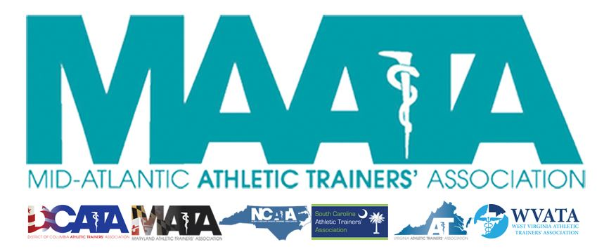

District Council Meeting Minutes
May 14, 2020
2:00pm

- Call to Order
  - Director Flanagan called the meeting to order at approximately 2pm.
- Roll Call:
  - Members Present:
    - Katie Walsh Flanagan – District Director
    - Jason Mitchell – District Secretary
    - Ray Davis – District Treasurer
    - Patricia Aronson – Past District Director
    - Michael Walker – President, DCATA
    - Wes Robinson – President, MATA
    - Jim Bazluki – President, NCATA
    - Brad Drake – President, SCATA
    - Danny Carroll – President-Elect, VATA
    - Jenni Johnson – President, WVATA
    - Grace Mills – Student Senate President
  - Guests Present:
    - Marty Sataloff –District Parliamentarian
    - Jay Sedory – District Treasurer-Elect
    - Gina Palermo – President-Elect, MATA
    - Scott Cook – Annual Meeting Planner
    - Kim Pritchard – Educational Program Chair
    - Emily Hildebrand – Student Senate Faculty Advisor
  - Members Absent:
    - Chris Jones – President, VATA

- Secretary Updates – Secretary Mitchell
  - Seek approval of minutes of District Council Meeting – Conference Call (05/05/2020) – Secretary Mitchell
    - Motion to approve – Wes Robinson
      - 2nd – Jim Bazluki
      - No discussion
      - Passed – 9-0-0
- MAATA Meeting update:
  - Scott Cook – Annual Meeting Planner
    - Discussed cancellation/planning process of 2020 Annual Meeting
    - 2021 meeting updates
  - Kim Pritchard – Educational Programming Update
    - Discussed E-Learning platform that will open to all NATA members next week
  - Emily Hildebrand & Grace Mills – Student Symposium Update
    - Discussed details of the Student Quiz Bowl that will be held tomorrow evening
    - Student Free Communication
      - Created virtually record session, that will be posted on our MAATA website
    - Working with the YPC for this year’s Career Workshop this upcoming Sunday
      - Conducting virtual mock interviews & resume/cover letter Q&A
- Secretary Report – Jason Mitchell
  - Discussed District Membership data
    - Motion to approve Secretary’s report – Michael Walker
      - 2nd – Jenni Johnson
      - No discussion
      - Passed – 9-0-0
- Treasurer Report – Ray Davis
  - Discussed 2020 expenses/finances and upcoming budget
    - Motion to approve Treasurer’s report – Michael Walker
      - 2nd – Wes Robinson
      - No discussion
      - Passed – 9-0-0
- MAATA Updates
  - Request for New Committee
    - Historical Commission – John Bielawski
      - Approved by the Executive Council
      - Seek motion to approve to the addition of this new committee
        - Motion to approve - Jenni Johnson
        - 2nd - Michael Walker
        - Passed – 9-0-0
  - By-Laws updates
    - Initial discussions on processes/timelines for Presidential & Vice-Presidential elections
    - Further discussion will take place in DC meeting June
  - Summer Awards Newsletter
    - Director Flanagan encouraged states to send all photos & descriptions to her & Secretary Mitchell
  - ***NC President Jim Bazluki had to sign off of meeting due to work conflict***
  - Volunteerism
    - Criteria for volunteers located on MAATA website (e.g. NPI, BOC, State Licenses, resume, letter of interest)
  - Fall/Spring Newsletter
    - Encouraged states to submit materials for each newsletter as it’s their time to shine
  - Saturday Business Meeting
    - Free registration, ending tonight
    - EBP Session – Rod Walters
    - Honors & Awards, all committee report slides, and Business Meeting slides will be posted in the Members section within the MAATA website
  - E-Learning opportunity
    - Registration May 18-June 5
      - Must complete sessions/evaluations by June 15
- MAATA Committee Reports
  - Reviewed submitted Annual reports
    - State Presidents were tasked with reviewing each Committee Chair’s evaluation of their respective state reps
- NATA News/Updates

- State Presidents’ Reports
  - District of Columbia – President Michael Walker
    - Nothing to report since last week
  - Maryland – President Web Robinson
    - Currently working on creating their online symposium
  - North Carolina – President Jim Bazluki
    - not present to provide report
  - South Carolina - President Brad Drake
    - Finalized RFP to legislature
    - Continue to work with their online symposium
  - Virginia – President Chris Jones
    - Nothing new to report since last week
  - West Virginia – President Jenni Johnson

- Student Senate Report – Grace Mills
  - First year that Student Senate included professional students
  - Summer Plans
    - Seniors coming up with survey for student program planning

- Additional news/updates
- Motion to adjourn – Jenni Johnson
  - 2nd – Jason Mitchell
  - No Discussion
  - Director Flanagan adjourned the meeting at 3:23pm

