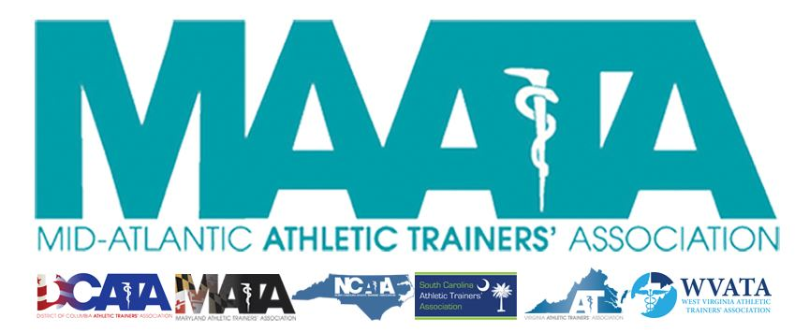

District Council Conference Call Minutes
March 16, 2021
7:30pm

- Call to Order

  - Director Flanagan called the meeting to order at approximately 7:30pm.

- Roll Call:

  - Members Present:
    - Katie Walsh Flanagan – District Director
    - Jason Mitchell – District Secretary
    - Jay Sedory – District Treasurer
    - Patricia Aronson – Past District Director
    - Gina Palermo – President, MATA
    - Meredith Petschauer – NC-appointed represented
    - Jeremy Searson – President, SCATA
    - Zach Garrett – President, WVATA

  - Guests Present:

    - Steve Cole – District President-Elect
    - Donita Valentine – District Vice-President-Elect
    - Marty Sataloff –District Parliamentarian
    - Scott Cook – Annual Meeting Planner
    - Emily Hildebrand – Student Senate Advisor

  - Members and Guests Absent:

    - Michael Walker – President, DCATA
    - Chris Jones – President, VATA
    - Kaitlyn Whipp – Student Senate President

- District Secretary – Jason Mitchell
  - Approval of minutes of District Council Meeting – (02/12/2021)
    - Motion to approve – Jeremy Searson
      - 2nd – Jay Sedory
      - No discussion
      - Passed – 7-0-0

- District Director – Katie Walsh Flanagan
  - Article 3.1.1 of By-Laws needs to be corrected
    - Approved by Executive Council on 03/15/2021
    - States “Serve as chair and spokesperson for the Executive and District Councils; and preside over all District Meetings”
      - This duty is now under the District President, as per Article 3.2.1
    - Seek a motion to approve corrections to Article 3.1.1 of By-Laws to be presented to the membership
      - Motion – Zach Garrett
        - 2nd – Meredith Petschauer
        - No discussion
        - Passed – 7-0-0
  - Reviewed results of recent Eblast polling members’ thoughts on attending in-person/live Annual Meeting
    - Membership responses were evenly split between “yes/no/maybe”
    - Approved by Executive Council to shift to a virtual, live Business Meeting on 03/15/2021
      - Also, looking to hold a virtual MAATA (“vMAATA”) with CEU opportunities available from May 17-Jine 17, 2021
    - Seek a motion to shift to a virtual, live Business Meeting
      - Motion – Zach Garrett
        - 2nd – Jay Sedory
        - Discussion
          - Zach Garrett inquired about ramifications of not having the in-person meeting with our contracted hotel
            - Director Flanagan discussed the financial costs & penalties that District would incur along with the high probability of significantly less revenue due to low attendee numbers.
          - Further discussion of the coordination of cancellation deadlines with hotel with the NC Governor COVID status for the state.
            - The NATA & all other Districts have gone virtual (except D6 who is still waiting as their meeting is late-July).
        - Passed – 7-0-0
  - Seek motion to pivot to a virtual Annual Symposium – “vMAATA”
    - Approved by Executive Council on 03/15/2021
    - Motion – Secretary Mitchell
      - 2nd – Zach Garrett
      - No discussion
      - Passed – 7-0-0
  - Reviewed dates of vMAATA CEU opportunities available from May 17-June 17, 2021
    - Director Flanagan addressed the scheduling of date/time of the virtual Business Meeting
      - Proposed Sunday, May 16th @ 1pm
      - Discussion of issues with religious and/or end-of-weekend issues that may affect attendance
        - Proposed sending a survey to the membership to ensure that the ultimate decision of day of week/time that reflects the least amount of bias toward any clinical setting.
    - An Eblast will be sent the membership tomorrow, stating that transition to vMAATA, and will note that the date/time of the Business Meeting is TBD.
  - Reviewed the membership dues distribution for qualified members that was approved by Executive Council on 03/15/2021
    - 100% of hardship ($20) dues go directly to the states, with an established maximum of 50 people
      - If/Once maximum is reached, hardship dues will be split 50/50 between the District/States
      - Establish a moratorium until March 2023

- Past District Director – Patricia Aronson
  - Compliments to the Student Senate for their clothing fundraiser
  - Discussed the need to hold an upcoming election this summer/fall for District Director, who will shadowing Katie Flanagan during her final year.
    - Added that we will also need to hold an election for District Treasurer as well, as Jay Sedory will be entering his final year of his current term

- Adjournment of meeting
  - Motion to adjourn meeting – Secretary Mitchell
    - 2nd – Jay Sedory
    - Approved 7-0-0
    - Meeting was adjourned 8:06pm.

