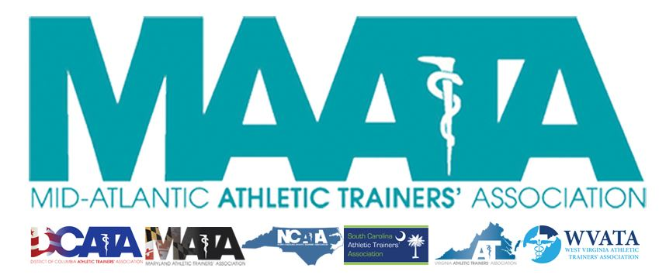

District Business Meeting Minutes
May 15, 2021
12:30pm

- Call to Order
  - Director Flanagan called the meeting to order at approximately 12:30pm.

- Huge thanks to the Annual Meeting Planning Committee for the transition to a virtual meeting
  - D3 is the 1st District to go virtual!

- Approval of minutes of 2020 Business Meeting (5/16/2020)
  - Motion to approve – Steve Cole
    - 2nd – Emily Hildebrand
    - Passed by online poll with 97%% approval

- Secretary Report – Jason Mitchell
  - Discussed District Membership data
  - Motion to approve –Steve Cole
    - 2nd – Emily Hildebrand
    - Passed by online poll with 100% approval

- Treasurer Report – Jay Sedory
  - Discussed 2020 expenses/finances and upcoming budget
  - Move to online system QuickBooks
  - Changed fiscal year to align with the NATA fiscal year
    - Proposed 2 budgets
      - One will that will go July 1-Dec 31 2021
      - 2nd will go for 2022 year
  - Moving into the future
    - We want to move more into savings
    - Review CDs & Interest Rates
    - Reviewing current policies & procedures
  - Motion to approve – Steve Cole
    - 2nd – Scott Cook
    - Passed by online poll with 99% approval

- New Business – Director Flanagan
  - Proposed Updates to the MAATA By-Laws
    - Requested Change:
      - Article 3.1.1 – Duplicity in District Director & District President noticed
        - Director Flanagan reviewed the year-long process to get to these recommended additions.
          - Both Executive & District Councils approved in Winter 2021
        - Motion to approve – Scott Cook
          - 2nd – Donita Valentine
          - Discussion - *was held thru virtual chat and monitored by Secretary Mitchell and Parliamentarian Sataloff*
            - Meeting continued for several minutes to allow members an opportunity to discuss, if needed
- MAATA News
  - District Council approved the 2023-2024
    - May 13-15, 2022 – Hilton Charlotte University Place in Charlotte, NC
    - May 17-19, 2023 – Founders Inn, Virginia Beach, VA
    - May 17-19, 2024 – Founders Inn, Virginia Beach, VA
  - E-Learning begins this upcoming Monday!
    - Student Symposium will begin tomorrow!
      - Many thanks to Emily Hildebrand for her work
    - Will include up to 13 Category A CEUs
  - New NATA committees seeking representation
    - EPC – Early Professional Committee
      - Original Young Professionals’ Committee was split into 2 groups
      - EPC will represent those in the first 6 years of Certification
      - YPC will represent those within 7-12 years of Certification
    - CEC – Connectivity & Engagement Committee
      - This committee is replacing the PR committee
      - Designed to get ATs within States & Districts engaged with items occurring at the National level
      - MAATA created a new Social Media Director
        - Kassy Mosley will be our 1st representative!
  - Be on the lookout for the upcoming August/September Eblast for calls for Volunteers
  - Monday, May 17 – all MAATA & NATA reports, Hall of Fame & Business Meeting slides will be posted to the MAATA website member section
  - Honors & Awards
    - MAATA Quiz Bowl Winner
      - Charleston Southern (SC)
        - Devynn Galloway/Lauren Halliday/Megan O’Dell
    - MAATA Hall of Fame Class of 2021
      - Scott Barringer
      - George Wham
    - District Director’s Award 2021
      - Ray Davis Jr
      - Tina Carrillo
    - Scholarship Winners
      - Edward Block scholarship
        - Renee Adamonis
        - Breanna Fergson
      - AC Whitey Gwynne scholarship
        - Emily Meyerl
        - Ashlee Humphries
      - Larry Sutton scholarship
        - Kimberly Hill
        - Kaitlyn Whipp
      - William Prentice scholarship
        - Janese Malone
      - NATA Foundation scholarship awards
        - Renee Adamonis/Breanna Ferguson/Ashlee Humphries/Kiara Malone/Rachel Scherbenske/Reann Young/Victoria Simpson/Kaitlyn Whipp/Derek Dewig/Ann Francis/Natalie Kupperman/Nancy Uriegas
        - Free Communications
          - Kennedy Dewey/Xavier Thompson/Daniel Clifton
        - Research Grants
          - Students
            - Alexandra DeJong/Daniel Torp
          - Professional
            - Eric Wikstrom

- New Business continued – Director Flanagan
  - Secretary Mitchell review substantive comments made within discussion
    - No discussion
    - Member Voting – proposed MAATA By-Law changes
      - Passed by online poll with 98% approval

- NATA News – Director Flanagan
  - Proposed Updates to the NATA By-Laws
    - Addition of District XI
    - Changed the ability to change by-laws to all Districts have a vote
    - Only active, certified NATA members can hold a seat on the BOD
      - Motion to approve – Donita Valentine
        - 2nd – Jason Mitchell
        - Discussion - *was held thru virtual chat and monitored by Secretary Mitchell and Parliamentarian Sataloff*
          - Meeting continued for several minutes to allow members an opportunity to discuss, if needed
  - NATA President Dieringer will be taking office mid-June at the NATA BOD Annual Meeting
  - Diversity, Equity, Inclusion & Access (DEI & A)
  - District 4 (GLATA) Re-structuring Approved
    - Approved 2 Districts
      - District 4 (IN, MI, OH)
      - District 11 (IL, MN, WI)
        - Director – Ryan Wilkerson
  - NATA has partnered with MVP Parent Magazine
    - This year will be posting monthly articles on athletic training & ATs
    - This magazine reaches parents of athletes (mvpparent.com)
  - Board of Certification
    - BOC Specialty Council
      - Now Board Certified Specialist – Orthopedics
    - After this current reporting period
      - No EBP requirements, as all talks will need to include evidence
      - Begins in 2022
    - BOC 360
      - New platform for reporting CEs, coming this summer
  - NATA Awards
    - Young Professionals’ Committee National Distinction Award
      - Tina Carrillo
    - LGBTQ+ Award for Inclusive Excellence
      - Pat Aronson
  - Secretary Mitchell review substantive comments made within discussion
    - No discussion
    - Member Voting – proposed NATA By-Law changes
      - Passed by online poll with 99% approval
        - 174-1-1
  - Future NATA meetings
    - 2022 – June 17-20 in Philadelphia, PA

- Announcements – Director Flanagan
  - Up next is Drs. Jochimsen & Baez are presenting “The Who, When & How of Mental Health Screening in Athletes”

- Adjournment – Director Flanagan
  - Motion – Emily Hildebrand
    - 2nd – Jason Mitchell
    - Meeting was adjourned 1:24pm.

- CE Presentation

