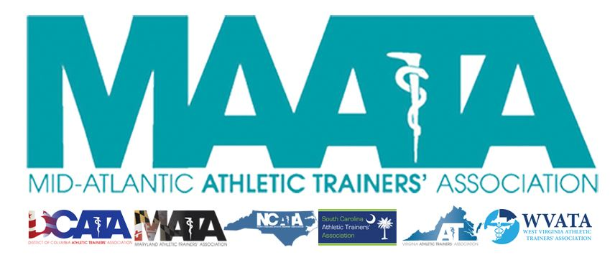

District Council Conference Call Minutes
February 12, 2021
9:00am

- Call to Order

  - Director Flanagan called the meeting to order at approximately 9 am.

- Roll Call:

  - Members Present:
    - Katie Walsh Flanagan – District Director
    - Jason Mitchell – District Secretary
    - Jay Sedory – District Treasurer
    - Patricia Aronson – Past District Director
    - Michael Walker – President, DCATA
    - Gina Palermo – President, MATA
    - Jim Bazluki – President, NCATA
    - Jeremy Searson – President, SCATA
    - Zach Garrett – President, WVATA

  - Guests Present:

    - Steve Cole – District President-Elect
    - Donita Valentine – District Vice-President-Elect
    - Marty Sataloff –District Parliamentarian
    - Scott Cook – Annual Meeting Planner
    - Emily Hildebrand – Student Senate Advisor

  - Members and Guests Absent:

    - Chris Jones – President, VATA
    - Kaitlyn Whipp – Student Senate President

- District Secretary – Jason Mitchell
  - Approval of minutes of District Council Meeting – (11/18/2020)
    - Motion to approve – Treasurer Sedory
      - 2nd – Jim Bazluki
      - Discussion – DC President noted discrepancy in minutes regarding the timing of his final term, ending this May.
    - Secretary Mitchell sought an amendment to correct that information within the minutes
      - Motion to approved amended minutes – Treasurer Sedory
        - 2nd – Jim Bazluki
        - No further discussion
        - Passed – 8-0-0
  - Reviewed updated membership data.
    - Now that we have entered February, we now have a more-accurate look of our member numbers now that lapsed-memberships have been removed.
      - These lowered membership numbers from previous years will need further discussion by DC, as this affects the amount of monies that each state receives.
    - DST committee continues to look at initiatives on how to increase/retain membership

- MAATA Annual Meeting Planner – Scott Cook
  - Registration opened Feb 1, with early registration going through April 30
  - Hotel has given us until Feb 28 to discuss changing/cancelling any & all portions of our current year’s meeting
    - Director Flanigan discussed that the NC Governor is making an update announcement on Feb. 28 about state restrictions moving forward
    - Working with HelmsBriscoe to negotiate with hotel as the newly announced restrictions allow.
  - Future planning for 2022-beyond meetings with the Site Selection Committee has begun

- District Director – Katie Walsh Flanagan
  - NATA updates
    - Diversity Equity and Inclusion (DEI) initiatives
      - Putting forth a document that’s inclusive/embracive, with strong language to showcase the organization’s stance
    - Committee Updates
      - Public Relations committee has been dissolved
        - Tina Carrillo has agreed to stay on, in a social media role, until May with D3
        - New committee will be Connectivity and Engagement, and is coming soon!
      - Young Professionals Committee is splitting into 2 entities
        - One committee with be to serve newly-certified professionals, with the 2nd committee focusing on <12yrs certified professionals.
    - Membership updates
      - NATA has made a clear push to encourage members who are struggling, to please contact the NATA office
        - Programs are in place to help struggling members, but are not publicized, and require members to contact office to inquire further.
      - Highest membership total was back in 2017 at 47,120
        - BOC has 54,000 individuals, worldwide, who hold an AT credential
    - NATA Annual Campaign
      - This year’s theme is “Built For This”
        - Throughout the year, they will focus on 1 of the 5 domains of AT
    - NATM
      - Essential to Healthcare
    - NATA Annual Meeting
      - Will be virtual this year
        - Current details are TBD
      - This year’s theme: “Always Evolving”
    - BOC
      - Upcoming platform, BOC 360, is replacing BOC-Central and hub for CE reporting
      - With constant improvements is all CE offerings, EBPs will be discontinued after the current reporting year.
    - KSI’s AT Location Services for SS (ATLAS)
      - Identify schools who have access to AT services
      - Updated every 2 years
        - DC – 58%
        - MD – 71%
        - NC – 72%
        - SC – 80%
        - VA – 69%
        - WV – 43%
    - Team Up For Sports Safety (TUFSS)
      - Meet up with state officials to go over safety policies & procedures
        - Coming to SC this month
        - Coming to MD & WV in October
    - NATA/APTA joint statement
      - NATA BOD voted/approved this milestone document
  - MAATA updates
    - Call for Volunteers
      - Encouraged State Presidents to find members who have energy and drive to serve in their respective committee roles
      - Looking for: Annual Meeting Planner & Educational Program Committee Chair
    - By-Laws update
      - Need to make a couple small adjustments with the addition of the District President
    - Summer Newsletter
      - Looking for any photos of H&A from respective states to showcase our members!
    - EC positions transition
      - Director Flanagan discussed with DC, of her meetings with both Steve & Donita, at a minimum of every 2 weeks
        - Both District President/Vice-President elect have been periodically taking on additional tasks, to optimize their taking over those roles this May

- District President-Elect – Steve Cole
  - Working hard with involving State Presidents regarding the onboarding of position appointments
  - Encouraged State Presidents to include him on any state-wide Eblasts/Newsletter

- District Vice-President-Elect – Donita Valentine
  - Donita needs to leave call for another engagement, but Director Flanagan discussed her recent meeting with Sheila Gordon/Secondary Schools.
    - Will be opening soon, the State School Award Grant
      - May be adjusting the process to increase transparency in awarding process

- Student Senate Updates: Emily Hildebrand
  - Discussed the ongoing monthly Student Senate newsletters
  - Service Project
    - Asking for an AT in need from each state, who could benefit from this service.
    - Raising funds through an online clothing sale

- State Presidents Reports:
  - District of Columbia – Michael Walker
    - COVID numbers on an overall downward trend
      - DC public schools starting to open back up, starting with hybrid models
    - Recently held elections, should have new lineup starting Monday.
    - Holding state meeting in May, for the first time in 3 years

  - North Carolina – Jim Bazluki
    - NCATA has decided to hold CE meetings virtually
      - Holding monthly Zoom CE events in February/March/April
      - Hosting a 2-hour live event when Annual Meeting is typically held
    - Discussed issues with the state allowing access to COVID vaccinations for ATs in all settings.
    - Many ATs have conducted additional training to be able to administer vaccinations throughout the state.

  - Maryland – Gina Palermo
    - Currently scheduling Annual Symposium, most likely in the Spring (May/June)
    - COVID Vaccinations
      - Have seen challenges with ATs (outside of hospital systems) having access to the vaccine.

  - South Carolina – Jeremy Searson
    - Working with lobbyist, hoping to have the licensure bill up in the next couple of weeks
    - TUFSS coming next week on February 23
    - Trained about 600 ATs to provide vaccinations
      - Continued to work on different settings to recognize that ATs can provide this service
    - Looking into a hybrid model for state symposium in July

  - West Virginia – Zach Garrett
    - Legislative sessions just opened up
      - Met with lobbyist this past week,
      - Pushing a heat-illness bill to continue improving area that have inadequate care
    - Working on virtual meeting
      - 2-day event (March 27 & April 18)
      - Student meeting on April 17
    - Readdressed the state statistics from ATLAS
      - WV stats are most likely lower than reported, representing those who have AT access year round
      - Hoping to meet with Board of Education in the coming weeks to discuss current/upcoming policies

- Other Updates
  - Part-Director Aronson
    - Discussed the upcoming announcement for the election of a new District Director
    - Pushing candidates to submit materials this upcoming summer, with election in the Fall
      - Elected candidate will shadow throughout the winter/spring

- Adjournment of meeting
  - Motion to adjourn meeting – Jim Bazluki
    - 2nd – Zach Garrett
    - Approved 8-0-0
    - Meeting was adjourned 10:03am.

