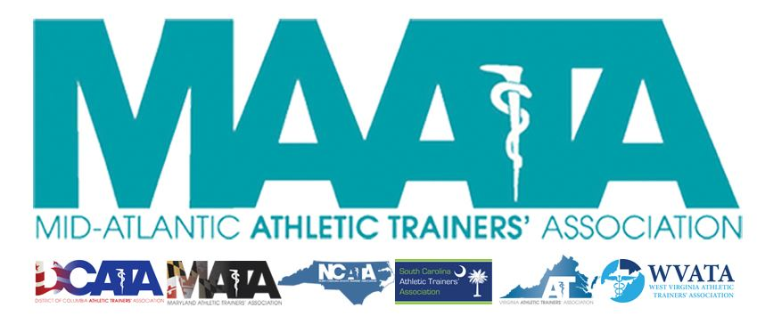

District Council Conference Call Minutes
November 18, 2020
11:00am

- Call to Order

  - Director Flanagan called the meeting to order at approximately 11am.

- Roll Call:

  - Members Present:
    - Katie Walsh Flanagan – District Director
    - Jason Mitchell – District Secretary
    - Jay Sedory – District Treasurer
    - Michael Walker – President, DCATA
    - Gina Palermo – President, MATA
    - Jim Bazluki – President, NCATA
    - Jeremy Searson – President, SCATA
    - Zach Garrett – President, WVATA

  - Guests Present:

    - Steve Cole – District President-Elect
    - Donita Valentine – District Vice-President-Elect
    - Marty Sataloff –District Parliamentarian
    - Scott Cook – Annual Meeting Planner
    - Emily Hildebrand – Student Senate Advisor

  - Members and Guests Absent:

    - Patricia Aronson – Past District Director
    - Chris Jones – President, VATA
    - Kaitlyn Whipp – Student Senate President

- District Secretary – Jason Mitchell
  - Approval of minutes of District Council Meeting – (08/07/2020)
    - Motion to approve – Treasurer Sedory
      - 2nd – Jim Bazluki
      - No discussion
      - Passed – 9-0-0
  - Welcome to the new officers within the DC!
  - Updates on DST database
    - Database is up and running. Please continue to let me know if you notice any data discrepancies.
    - Reminder to all DC officers that information within the database is for internal use only and is not to be distributed for personal/commercial reasons.
  - Reminder to all officers the importance of including updates within District-wide Eblast & Newsletter correspondence, as this may be the only time members access information

- District Treasurer – Jay Sedory
  - Treasurers within the DST committee going through some Best Practices review.
  - Discussed the updated Purchase Request Form
    - Will be within the District Council Dropbox

- District President-Elect – Steve Cole
  - Director Flanagan officially welcomed Steve Cole, who will officially take off in May 2021
  - President-Elect Cole thanked members of the DC who have helped with
  - Point-of-Order to Parliamentarian Sataloff
    - Wanted clarification & confirmation that both he, and Vice-President-Elect Valentine do not have voting privileges within the District Council until they officially take office this upcoming May
    - Parliamentarian Sataloff confirmed

- District Vice-President-Elect – Donita Valentine
  - Director Flanagan officially welcomed Donita Valentine, who will officially take off in May 2021
  - Vice-President-Elect Valentine expressed her excitement to being working with all the members of the DC

- MAATA Annual Meeting Update – Scott Cook
  - Details of the Annual Meeting in May is still in a fluid state
  - Sent out a survey to the membership in early November to gauge their feelings in attending an in-person meeting
    - Responses split equally in thirds, between yes they would attend/no they won’t/undecided
  - Continuing to monitor the status of the state of North Carolina, along with the relationship with HelmsBriscoe
    - Current contract allows us to cancel our event with the hotel up until February 15
      - This would result in ~25% penalty fee, equally to about $25k
      - Penalties increase as we get closer to the event date
    - There are possibilities to renegotiate our current contract with the hotel if we feel our attendance numbers will continue to be significantly affected
  - Registration has been postponed until January, and will only have 2 periods (advanced & on-site)
  - Beginning future site-selection process with HelmsBriscoe sometime mid-February

- District Director – Katie Flanagan
  - MAATA Updates
    - Reviewed & updated the members of the District Council who will act as a DC liaisons to MAATA Committees (see https://www.maata.org/maatacommittees )
    - Volunteers added to committees – NATA (starting in June)
      - Nancy Burke (VA) NATA HOF committee
      - Michael Higgins (VA) Convention Planning Committee
      - Ed Strapp (MD) Governmental Affairs Committee
    - Volunteers added to MAATA committees
      - State representatives to Young Professionals
        - Steve Taylor (DC)
        - Samantha Scarneo-Miller (WV)
      - State representative to the Scholarship Committee
        - Jim Berry (SC)
      - State representative to the Historical Commission
        - Randy Meador (WV)
    - Reminder about your volunteers: engaged, present, communicative
    - For the Summer Awards Newsletter – send Photos and descriptions to Director Flanagan
    - Volunteers – criteria on webpage (NPI, BOC, State License, resume, specific letter)
    - Fall/Spring Newsletters – your time to shine! (Eblasts too!!)
  - NATA Updates
    - Diversity Equity Inclusion Efforts
    - Will be meeting with NATA next week
      - Will get the 2020 VNATA numbers
      - Current status of 2021 NATA annual meeting is unknown
      - Joint Committee meetings in January will be virtual

- Student Senate Updates: Emily Hildebrand
  - Discussed upcoming communications with the State Presidents from their respective Student Senators for information on their upcoming Newsletter.

- State Presidents Reports:
  - District of Columbia – Michael Walker
    - DC is currently not implementing any additional COVID restrictions
    - Public/Private schools are still looking at a 3-season model starting in January
    - Still waiting on the Board of Medicine to move forward with licensure
    - Hosting Business Meeting next month
    - President Walker is in the final stretch of his term, finishing up after May. Will begin officer elections in the next couple months. Tina Carillo will take over as DC President at that time.

  - Maryland – Gina Palermo
    - With current COVID case rates, MD hospitals are closing in on max capacities
    - MD is allowing public school districts to decide what they want to do with proceeding with sporting events

  - North Carolina – Jim Bazluki
    - Public school districts have started noticing slight upticks in COVID cases within their high school athletics programs, so each district is working on management strategies
    - State annual meeting is typically held in mid-March, but NCATA has made decision to move to completely virtual

  - South Carolina – Jeremy Searson
    - Continuing to work with their credentialling body with COVID testing, with transitioning to vaccinations. Hope is to get as many ATs trained and to be involved as they can, so that they can keep those in the state practice act “post-COVID”
    - SCATA is appointing a lead to their social media accounts and potential software additions to increase the association’s footprint.
    - Increasing lobbyist efforts to push towards licensure
      - Working over the next week or 2 to get first lobbyist under contract with hopes of moving towards licensure in January
    - Annual State meeting
      - Hotel allowed association to pull out of their rooming agreement
    - Looking into reorganizing the structure of the association to approve their communications to their members

  - Virginia –
    - Scott Cook provided update of state annual meeting
      - Has gone virtual, being help January 8-10

  - West Virginia – Zach Garrett
    - Governor shut down all secondary school winter athletics
      - Athletics schedules to resume in January
    - Will be meeting next week on determining status of upcoming state meeting
    - Currently in redesigning phase in their website, which should be completed in the upcoming weeks.
    - Currently working on switching to a new lobbyist

- Other Updates
  - Parliamentarian Sataloff encouraged the District Council to consider holding off any significant Constitution & By-Laws changes until the new President & Vice-President officially come aboard in May.
  - Emily Hildebrand announced that, regardless of state meetings going in-person or virtual, the Student Senate is planning on having quiz bowls.

- Director Flanagan adjourned the meeting at 12:19pm.

