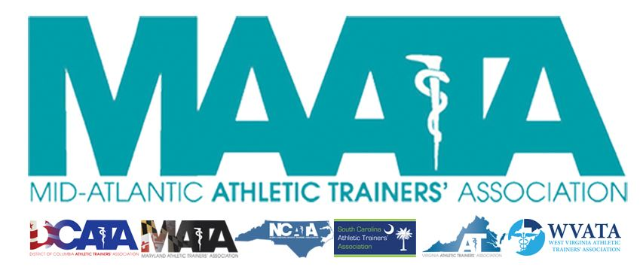

District Council Conference Call Minutes
May 5, 2020
2:00pm

- Call to Order

  - Director Flanagan called the meeting to order at approximately 2:04pm.

- Roll Call:

  - Members Present:
    - Katie Walsh Flanagan – District Director
    - Jason Mitchell – District Secretary
    - Ray Davis – District Treasurer
    - Patricia Aronson – Past District Director
    - Michael Walker – President, DCATA
    - Wes Robinson – President, MATA
    - Jim Bazluki – President, NCATA
    - Brad Drake – President, SCATA
    - Danny Carroll – President-Elect, VATA
    - Jenni Johnson – President, WVATA

  - Guests Present:

    - Marty Sataloff –District Parliamentarian
    - Jay Sedory – District Treasurer-Elect

  - Members Absent:

    - Chris Jones – President, VATA

- NATA updates – Director Flanagan
  - Annual Meeting in Atlanta has been cancelled
    - Plan moving forward for virtual options
    - BOD planning for accommodations for Honors & Awards recipients
  - Discussed upcoming ATs Care Call-In Events, which Secretary will share more later on.

- Virtual Annual Business Meeting & Online CE opportunities – Director Flanagan
  - Director Flanagan discussed process for membership to gain access to upcoming virtual offerings
  - Membership will be emailed a link Monday May 11 to register for free event
    - Includes Annual Business meeting at 1.5 EBP education session
  - Online at-home educational sessions will be opened Monday May 18, for all NATA members to purchase a-la-carte.
    - Registration available for 3 weeks, allowing members 4 weeks for completion
    - Up to 12 CEUs available
  - Director Flanagan discussed the process to present the proposed Constitution & By-Laws amendments to the membership
    - Proposed Constitution amendments have be presented online in accordance to the current Constitution/By-Laws
    - Director Flanagan will post Friday May 15, her presentation of the proposed By-Laws amendments, as directed by the current Constitution/By-Laws
    - Motion to approve the Virtual meeting format – Secretary Mitchell
      - 2nd – Danny Carroll
      - No discussion
      - Passed – 9-0-0
  - Director Flanagan discussed that voting with take place in 2 different formats
    - Business meeting will be held virtually via Zoom webinar from Saturday, May 16th @ 12:30pm to Monday, May 18th @ 11:59PM
    - During the Virtual Business Meeting, the proposed Constitution amendments will need a motion, a second, and will hold discussion via the Zoom chat function for 10 minutes. Afterwards the members will have the opportunity to vote via a Zoom poll
      - Motion to dates/times for Business meeting and format for live voting for proposed Constitution amendments – Brad Drake
        - 2nd – Mike Walker
        - No discussion
        - Passed – 9-0-0
    - If Constitution amendments are approved, then the By-Laws amendments will be presented, and will need a motion, a second, and will hold discussion via the Zoom chat function for 10 minutes. Afterwards, voting for the proposed amendments will take place via a closed online survey.
      - Motion to approve the extended dates/times for Business meeting to accommodate membership voting for proposed By-Laws amendments via online survey – Jenni Johnson
        - 2nd – Jim Bazluki
        - No discussion
        - Passed – 9-0-0
  - Applauded all members of the Annual Planning committee for their tireless efforts in getting these resources to our members!
- Secretary Updates – Secretary Mitchell
  - Seek approval of minutes of District Council Meeting – Conference Call (04/06/2020) – Secretary Mitchell
    - Motion to approve – Danny Carroll
      - 2nd – Mike Walker
      - No discussion
      - Passed – 9-0-0
  - Discussed ATs Care Call-In Events. Secretary Mitchell will be sending State Presidents event information to send to their PR departments to send out to the membership.
- Miscellaneous Announcements/Comments
  - Discussed scheduling of District Council meeting to approve Secretary’s & Treasurer’s reports prior to the Annual Business meeting
    - Executive Council meeting scheduled Thursday, May 14 @ 1pm EST
    - District Council meeting scheduled Thursday, May 14 @ 2pm EST
- State Updates
  - District of Columbia
    - Met with Board of Medicine last week, proposed amendments weren’t implemented as desired.
      - Coming up with new strategies to get amendments to read how DC wants them to look.
  - Maryland
    - Public schools officially closed until May 15, but this is anticipated to be extended
    - Ed Strapp did great work for MD with an article in the Baltimore Sun last week
    - Working on details to moving their State Annual Meeting to a virtual platform
  - North Carolina – Jim Bazluki
    - Discussed current lifts of stay at home orders,
    - Discussed AT who have been furloughed, along with AT reassignments/redeployments
  - South Carolina – Brad Drake
    - State Annual Meeting is schedule in July
      - Making contingency plans if in-person meeting needs to be cancelled
    - SC reduced some restrictions of the stay at home order yesterday, so some progress is showing
  - Virginia – Danny Carroll
    - VA announced yesterday possibility of opening up some non-essential business to the public as soon as next Friday (May 15)
    - In initial planning of next year’s State Annual Meeting
  - West Virginia – Jenni Johnson
    - Starting Phase II of state reopening, including reopening of non-essential businesses
    - Hoping to start Phase III next week
      - Should help furloughed AT with the reopening of therapy clinics
    - Working to ensure inclusion of an AT on the state task-force for reopening of public schools.

- Final Announcements/Comments
  - Past Director Aronson discussed potential upcoming elections schedule for District President & Vice-President

- Director Flanagan adjourned the meeting at 2:54pm.
  - Motion to adjourn meeting – Brad Drake
  - 2nd – Danny Carroll

