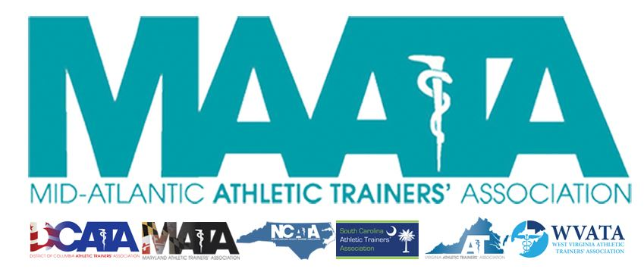

District Council Conference Call Minutes
August 7, 2020
8:00am

- Call to Order

  - Director Flanagan called the meeting to order at approximately 8am.

- Roll Call:

  - Members Present:
    - Katie Walsh Flanagan – District Director
    - Jason Mitchell – District Secretary
    - Jay Sedory – District Treasurer
    - Patricia Aronson – Past District Director
    - Michael Walker – President, DCATA
    - Gina Palermo – President, MATA
    - Nina Walker – Vice-President, NCATA
    - Jeremy Searson – President, SCATA
    - Chris Jones – President, VATA
    - Zach Garrett – President, WVATA

  - Guests Present:

    - Marty Sataloff –District Parliamentarian

  - Members and Guests Absent:

    - Jim Bazluki – President, NCATA

- MAATA Elections – District President & District Vice-President:
  - Director Flanagan discussed the timing of upcoming elections
    - As per the MAATA Constitution & By-Laws, elections must be complete by November 1
      - Elected officers will then shadow until after the District Meeting in May, then will take official office
    - Past Director Aronson addressed creation of Letter of Obligation for both positions
    - Discussion of holding election over a 2-3-week period in October
    - Initial announcement will be made in upcoming Eblast
      - More details will be sent to membership beginning of September

- District Secretary – Jason Mitchell
  - Approval of minutes of District Council Meeting – (05/14/2020)
    - Motion to approve – Michael Walker
      - 2nd – Chris Jones
      - No discussion
      - Passed – 9-0-0
  - Discussed DST database
    - Will continue to update each State’s Dropbox with membership data
    - There have been some technical issues with the DST database, resulting in not all membership data being available
      - Encouraged State Presidents to continue looking at membership data and notify Secretary Mitchell of any discrepancies

- District Treasurer – Jay Sedory
  - Will reach out to State Treasurers to ensure accurate contact information
  - Informing State Presidents on membership dues disbursements in the case a member pays for multiple years
    - States will receive a lump sum up front, not spread out over the course of that individual membership

- State Presidents Updates:
  - District of Columbia – Michael Walker
    - DC universities/colleges are showing a mix of all-virtual/hybrid models
    - Public high schools going completely virtual for upcoming year
    - Consensus for athletics beginning in January, with condensing all seasons

  - Maryland – Gina Palermo
    - Most universities are in-person instruction
      - Athletics varying in decision on proceeding with fall sports
    - Most public schools are going virtual for student learning
      - Regulations differing county to county
      - Most schools have cancelled all fall & winter sports
    - Private school are mostly going virtual, but some are still entertaining hybrid models

  - North Carolina – Nina Walker
    - Colleges still determining between student learning models
      - Athletic participation different between conferences
    - Since state is still in Phase 2, Governor stated that start date for high schools’ athletics will be pushed back past the initial September 1 date
      - Schools do have the opportunity to still conduct conditioning workouts if opted in
        - Only 40% of schools have opted to participate, with the remaining schools suspending all athletic activities indefinitely

  - South Carolina – Jeremy Searson
    - Up until now, the state has encouraged the wearing of face coverings, but will require usage once schools open up
    - High school athletics are still on day-to-day evaluation for operations
    - Private schools are opening next week, face-to-face everyday
    - Meeting with Department of Education, in conjunction with the nurses’ association, to extend the AT’s roll within schools to further assist with COVID-related care (i.e. testing/etc.)
      - Already receiving legislator & credentialing body support
    - SC Department of Health & Environmental Control is looking to form COVID testing teams
      - These will transition into vaccination teams
      - SC AT practice act allow AT involvement in these teams
        - Looking at trying to perform up to 500 test/month
        - Hoping to announce in the coming weeks the ability to start hiring ATs for these teams in the next couple of weeks

  - Virginia – Chris Jones
    - VHSL voted/announced that all sports will have condensed seasons, starting in January
      - Staggering seasons Winter to Fall to Spring sports
        - This will extend athletics past the completion of the school year
    - Only 2 counties are proceeding with a complete in-person learning
    - Most universities using hybrid learning models

  - West Virginia – Zach Garrett
    - Each university/college is granted autonomy to decide what’s best for them
    - Governor has mandated COVID testing of all faculty/staff/instructors for university/college/high schools
    - High school athletics are scheduled to begin August 17
      - Changes to current scheduling is expected in the coming weeks, as there have been recent positive COVID tests of some high school students

- Other Updates
  - ATs Care is holding several call-in sessions over the next couple of weeks discussing racial injustice/uncertainty/COVID.
    - Director Flanagan encouraged State Presidents & District Council on self-care, and understanding what our membership is encountering
  - Parliamentarian Sataloff discussed ways of having our District & National leaders help our membership who have concerns/difficulties/etc. with “being an island” with COVID enforcement in their respective areas

- Director Flanagan adjourned the meeting at 8:50am.

