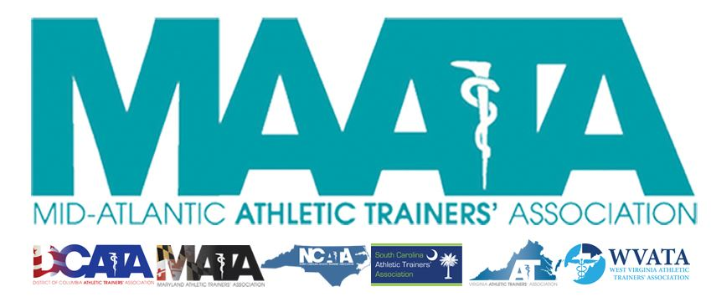

District Business Meeting Minutes
May 16, 2020
12:30pm

- Call to Order
  - Director Flanagan called the meeting to order at approximately 12:30pm.

- Establish a Quorum
  - Approved - Marty Sataloff – District Parliamentarian

- Huge thanks to the Annual Meeting Planning Committee for the transition to a virtual meeting
  - D3 is the 1st District to go virtual!

- Approval of minutes of 2019 Business Meeting (5/17/2019)
  - Motion to approve – Marty Sataloff
    - 2nd – Emily Hildebrand
    - Passed by online poll with 95% approval

- Secretary Report – Jason Mitchell
  - Discussed District Membership data
  - Motion to approve – Scott Cook
    - 2nd – Emily Hildebrand
    - Passed by online poll with 99% approval

- Treasurer Report – Ray Davis
  - Discussed 2019 expenses/finances and upcoming budget
  - Motion to approve – Scott Cook
    - 2nd – Emily Hildebrand
    - Passed by online poll with 98% approval

- New Business – Director Flanagan
  - Constitution Proposed Change
    - Requested Change:
      - The additions of a District President & District Vice-President
        - Director Flanagan reviewed the year-long process to get to these recommended additions
        - Motion to approve – Rod Walters
          - 2nd – Secretary Mitchell
          - Discussion - *was held thru virtual chat and monitored by Secretary Mitchell and Parliamentarian Sataloff*
            - Meeting continued for several minutes to allow members an opportunity to discuss, if needed
- MAATA News
  - E-learning start this Monday (May 18) – 12 Category A CEUs
  - New Commission added
    - Historical Commission
      - John Bielawski will serve as chair, along with state representatives
      - Memorial Resolutions will be a subcommittee, which will serve to honor members who have passed.
  - July Award Newsletter
    - Be on the lookout for this upcoming edition
      - Includes all Award & Scholarship winners!

- NATA News – Director Flanagan
  - District 4 (GLATA) Re-structuring was approved
    - Will split in 2 Districts:
      - District 4 – IN, MI, OH
      - District 11 – IL, MN, WI
    - It is intended that by 2021, all committees will have representatives from both Districts
  - ATs Care
    - This unit is a District-based critical incident team (not yet state-based)
    - Please utilize their services, especially in our current times with COVID.
  - Currently in review of NATA By-Law which will be further discussed in the most upcoming Board of Directors meeting
  - PASS – Program Assessment for Safety in Sport
    - A tool on www.nata.org to assess your secondary schools and medical care for secondary school athletes
  - ATLAS
    - Secondary Schools - please update your information annually
  - Sidelined USA
    - Resources for athletes no longer able/eligible to participate
  - Go4Ellis
    - Wonderful resource, and NATA-preferred provider for per diem work for ATs
  - BOC Specialty Council
    - Plan is to have an Ortho Exam in mid-2021
  - NATA Presidential Election
    - Voting in July
    - Read about both candidates in NATA News and on the NATA website
    - Please encourage everyone to vote
  - Future NATA meetings
    - 2020 – Virtual – TBD
    - 2021 – June 24-27 in Orlando, FL
    - 2022 – June 17-20 in Philadelphia, PA

- New Business continued – Director Flanagan
  - Parliamentarian Sataloff review substantive comments made within discussion
    - One question was regarding if a member, who is the District Vice-President, has the ability to “move up” to District President
      - Current proposed that both positions are independent of each other, to promote member involvement with not requiring long-term commitments
    - Another question requested clarification that one Task Force provided a recommendation of adding a President, but not a Vice-President, the District is proposing adding both positions
      - The Executive Council review the Task Force recommendations, but felt that the addition of the Vice-President would benefit the structure of the Annual Meeting, along with maximizing the tasks/responsibilities of the rest of the Executive Council
  - Member Voting – proposed constitution changes
    - Passed by online poll with 95% approval
  - By-Laws Proposed Changes
    - Request changes to reflect the approved addition of a District President & District Vice-President within the Constitution
      - Motion to approve – Rod Walters
        - 2nd – Treasurer Davis
        - Discussion - *was held thru virtual chat and monitored by Secretary Mitchell and Parliamentarian Sataloff*
          - Meeting continued for several minutes to allow members an opportunity to discuss, if needed

- Committee Reports – Director Flanagan
  - All MAATA & NATA Committee reports are posted on our website for membership review

- Honors & Awards – Director Flanagan
  - Announced all D3 District & National award winners

- New Business continued – Director Flanagan
  - Parliamentarian Sataloff review substantive comments made within discussion for proposed By-Law changes
    - Clarification between Section 3.1.1 & 3.2.1
      - Reviewed that District President will take over as chair of the Executive & District Councils from the District Director
    - Reviewed financial implications with addition of Executive Council members
      - Reference back to Treasurer Davis’ report which accounts for some potential increase in cost
    - Reviewed the duties between District President & Director in regards to committee chair appointments
      - District President will oversee all District-based committees, while the District Director will oversee all D3 representatives to NATA-based committees.
    - Vote was conducted post-meeting thru an external online vote
      - Results – passed by significant majority

- Announcements – Director Flanagan
  - Discussed procedures for obtaining CE certificate to the upcoming presentation by Dr. Rod Walters – “EAP for Safer Sports”
- CE Presentation – Dr. Rod Walters
- Final Remarks – Director Flanagan
  - Reviewed that attendees will receive an email with a link to vote for By-Laws.
    - Voting will close and the Annual Business meeting will officially adjourn at 11:59PM EST on May 18

