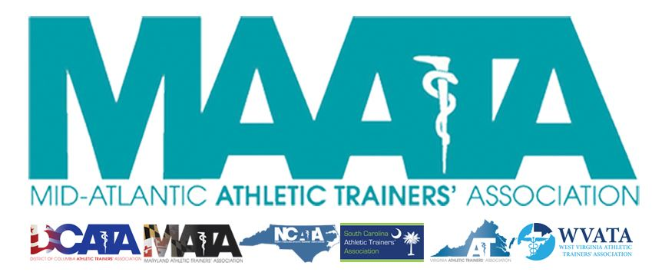

District Council Conference Call Minutes
May 13, 2022
10:00am

- Call to Order

  - President Cole called the meeting to order at approximately 10:00am.

- Roll Call:

  - Members Present:
    - Steve Cole – District President (via phone call)
    - Katie Walsh Flanagan – District Director
    - Donita Valentine – District Vice-President
    - Jason Mitchell – District Secretary
    - Jay Sedory – District Treasurer
    - Patricia Aronson – Past District Director
    - Christina Carrillo – President, DCATA
    - Jean Perez – President, MATA
    - Nina Walker – President, NCATA
    - Jeremy Searson – President, SCATA
    - Danny Carroll – President, VATA
    - Tom Belmaggio – President, WVATA

  - Guests Present:

    - Marty Sataloff – District Parliamentarian
    - Amy Hand – President-Elect, SCATA
    - Ray Davis – District Director-Elect
    - Emily Hildebrand – Student Senate Faculty Advisor

- District Treasurer – Jay Sedory
  - Discussed current finances
  - Discussed updates on creation of Finance Committee
    - Motion to approve – SC President Searson
      - 2nd – NC President Walker
      - No discussion
    - Passed – 11-0-0

- District Secretary – Jason Mitchell
  - Approval of minutes of District Council Meeting – (04/06/2022)
    - Motion to approve – WV President Belmaggio
      - 2nd – VA President Carroll
      - No discussion
    - Passed – 11-0-0
  - Membership stats report
    - Motion to approve Secretary’s report – Treasurer Sedory
      - 2nd – District Director Walsh Flanagan
      - No discussion
    - Passed – 11-0-0

- District President – Steve Cole
  - MAATA Governance Task Force
    - Discussed make up
    - District President will act as chair
      - District Parliamentarian will be included as an advisor
    - A representative of each state must be involved
      - District President & State President will coordinate representative
        - Must be in District 3 years out of the last 7
        - A minimum of 7 years of total service
        - Preferred DEI/State Executive/Diverse clinical setting
      - Call for Applications – June 1-30
      - Application Vetting – July 1-15
      - State President/District President – call approved candidates – July 16-30
      - Task Force Begins August 1
        - Task Force will complete work October 31

- District Director – Katie Walsh Flanagan
  - NATA Updates
    - Discussed potential membership dues increase
      - Based on timing of when the vote will be held at the NATA annual meeting will determine who will vote for D3
      - If held at beginning, Director Walsh Flanagan will vote,
      - At the end, Director-Elect Davis will officially take over
      - BOD vote is the official vote, as this doesn’t require full membership involvement
      - SC President Searson inquired if any progress had been made by the NATA in his inquiry at our past DC meeting, showing a study regarding potential attrition has been conducted if a membership rate increase is implemented. Also called if anything has been updated regarding the transparency of how the financial resources are allocated to show how membership dollars are being spent

- Other Updates
  - President Cole inquired to the DC members on who will be present at the NATA Annual Meeting in Philadelphia
    - Based on attendance, he will notify DC in the coming weeks if we have an EC, DC, or membership meeting in Philadelphia.

- Adjournment of meeting
  - Motion to adjourn meeting – Secretary Mitchell
    - 2nd – Treasurer Sedory
    - Approved 11-0-0
    - Meeting was adjourned 11:56am.

